# **Mybatis从入门到精通**

# 1 mybatis入门

## 1.1 Mybatis简介

## 1.2创建Maven项目

项目结构如下，结构比较简单

book1-mybatis-demo01

├── pom.xml

└── src

└── main

├── java

│   └── com

│   └── mybatis

│   └── book

│   └── study

│   ├── mapper

│   │   └── CountryMapper.java

│   └── model

│   └── Country.java

└── resources

├── log4j.properties

├── mappers

│   └── CountryMapper.xml

└── mybatis-config.xml

pom文件

|  |
| --- |
| <?xml version="1.0" encoding="UTF-8"?> <project xmlns="http://maven.apache.org/POM/4.0.0"  xmlns:xsi="http://www.w3.org/2001/XMLSchema-instance"  xsi:schemaLocation="http://maven.apache.org/POM/4.0.0 http://maven.apache.org/xsd/maven-4.0.0.xsd">  <modelVersion>4.0.0</modelVersion>   <groupId>com.mybatis.book.study</groupId>  <artifactId>book1-mybatis-demo01</artifactId>  <version>1.0-SNAPSHOT</version>    <properties>  <project.build.sourceEncoding>UTF-8</project.build.sourceEncoding>  </properties>    <dependencies>   <dependency>  <groupId>junit</groupId>  <artifactId>junit</artifactId>  <version>4.12</version>  </dependency>   <dependency>  <groupId>org.slf4j</groupId>  <artifactId>slf4j-api</artifactId>  <version>1.7.12</version>  </dependency>   <dependency>  <groupId>org.slf4j</groupId>  <artifactId>slf4j-log4j12</artifactId>  <version>1.7.12</version>  </dependency>   <dependency>  <groupId>log4j</groupId>  <artifactId>log4j</artifactId>  <version>1.2.17</version>  </dependency>   <dependency>  <groupId>mysql</groupId>  <artifactId>mysql-connector-java</artifactId>  <version>5.1.38</version>  </dependency>   <dependency>  <groupId>org.mybatis</groupId>  <artifactId>mybatis</artifactId>  <version>3.3.0</version>  </dependency>  </dependencies>   <build>  <plugins>  <plugin>  <artifactId>maven-compiler-plugin</artifactId>  <configuration>  <source>1.8</source>  <target>1,8</target>  </configuration>  </plugin>  </plugins>  </build>   </project> |

## 1.3简单配置让mybatis跑起来

### 1.3.1准备数据库

创建数据库mybatis-study

创建表country和处处海湖数据

|  |
| --- |
| create table country (  id int not null auto_increment,  countryname varchar(255) null,  countrycode varchar(255) null,  PRIMARY key (id)  );  INSERT into `country` (`countryname`,`countrycode`) values ('中国','CN'),('美国','US'),('俄罗斯','RU'),('英国','GB'),('法国','FR'); |

### 1.3.2配置mybatis

mybatis-config.xml

|  |
| --- |
| <?xml version="1.0" encoding="UTF-8"?> <!DOCTYPE configuration PUBLIC "-//mybatis.org//DTD Config 3.0//EN"  "http://mybatis.org/dtd/mybatis-3-config.dtd"> <configuration>  <settings>  <!-- 输出的日志-->  <setting name="logImpl" value="LOG4J"/>  </settings>   <typeAliases>  <!-- 实体对应的包-->  <package name="com.mybatis.book.study.model"/>  </typeAliases>   <!-- 数据源配置-->  <environments default="development">  <environment id="development">  <transactionManager type="JDBC">  <property name="" value=""/>  </transactionManager>  <dataSource type="UNPOOLED">  <property name="driver" value="com.mysql.jdbc.Driver"/>  <property name="url" value="jdbc:mysql://localhost:3306/mybatis-study"/>  <property name="username" value="root"/>  <property name="password" value="mysql"/>  </dataSource>  </environment>  </environments>    <mappers>  <!-- 映射文件所在位置-->  <mapper resource="mappers/CountryMapper.xml"></mapper>  </mappers>  </configuration>  <typeAliases>配置包的别名，主要是在mapper.xml文件的映射实体可以省略包名  <mappers>中配置了一个包含完整类路径的CountryMapper.xml |

### 1.3.3 创建实体和映射文件

在model包下创建实体Country

|  |
| --- |
| package com.mybatis.book.study.model;  public class Country {  private Long id;   private String countryname;   private String countrycode;   public Long getId() {  return id;  }   public void setId(Long id) {  this.id = id;  }   public String getCountryname() {  return countryname;  }   public void setCountryname(String countryname) {  this.countryname = countryname;  }   public String getCountrycode() {  return countrycode;  }   public void setCountrycode(String countrycode) {  this.countrycode = countrycode;  } } |

在src/main/resources/下创建mappers文件夹，在该文件夹下创建CountryMapper.xml

|  |
| --- |
| <?xml version="1.0" encoding="UTF-8"?> <!DOCTYPE mapper PUBLIC "-//mybatis.org//DTD Mapper 3.0//EN"  "http://mybatis.org/dtd/mybatis-3-mapper.dtd"> <mapper namespace="com.mybatis.book.study.mapper.CountryMapper">   <select id="selectAll" resultType="Country">  select id,countryname,countrycode from country  </select>  </mapper> |

### 1.3.4 配置Log4j

在src/main/resources/下创建log4j.properties

|  |
| --- |
| # 全局配置 log4j.rootLogger=ERROR, stdout # mybatis日志配置 log4j.logger.com.mybatis.book.study.mapper=TRACE #控制台输出配置 log4j.appender.stdout=org.apache.log4j.ConsoleAppender log4j.appender.stdout.layout=org.apache.log4j.PatternLayout log4j.appender.stdout.layout.ConversionPattern=%5p [%t] - %m%n |

### 1.3.5 编写测试用例

在src/test/java 中创建com.mybatis.book.study.CountryMapperTest

|  |
| --- |
| package com.mybatis.book.study;  import com.mybatis.book.study.model.Country; import org.apache.ibatis.io.Resources; import org.apache.ibatis.session.SqlSession; import org.apache.ibatis.session.SqlSessionFactory; import org.apache.ibatis.session.SqlSessionFactoryBuilder; import org.junit.BeforeClass; import org.junit.Test;  import java.io.IOException; import java.io.Reader; import java.util.List;  public class CountryMapperTest {   private static SqlSessionFactory *sqlSessionFactory*;   @BeforeClass  public static void init() {  try {  Reader reader = Resources.*getResourceAsReader*("mybatis-config.xml");  *sqlSessionFactory* = new SqlSessionFactoryBuilder().build(reader);  reader.close();  } catch (IOException e) {  e.printStackTrace();  }  }   @Test  public void testSelectAll() {  SqlSession sqlSession = *sqlSessionFactory*.openSession();  List<Country> countryList = sqlSession.selectList("selectAll");  printCountryList(countryList);  }   private void printCountryList(List<Country> countryList) {  for (Country country : countryList) {  System.*out*.printf("%-4d%4s%4s\n", country.getId(), country.getCountryname(), country.getCountrycode());  }  }  }  运行输出如下  DEBUG [main] - ==> Preparing: select id,countryname,countrycode from country  DEBUG [main] - ==> Parameters:  TRACE [main] - <== Columns: id, countryname, countrycode  TRACE [main] - <== Row: 1, 中国, CN  TRACE [main] - <== Row: 2, 美国, US  TRACE [main] - <== Row: 3, 俄罗斯, RU  TRACE [main] - <== Row: 4, 英国, GB  TRACE [main] - <== Row: 5, 法国, FR  DEBUG [main] - <== Total: 5  1 中国 CN  2 美国 US  3 俄罗斯 RU  4 英国 GB  5 法国 FR |

# **2 Mybatis XML方式的基本配置**

## 2.1 一个简单的权限控制需求

### 2.1.1 创建数据库表

|  |
| --- |
| create table sys_user(  id bigint not null auto_increment comment '用户Id',  user_name varchar(50) comment '用户名',  user_password varchar(50) comment '密码',  user_email varchar(50) comment '邮箱',  user_info text comment '简介',  head_img blob comment '头像',  create_time datetime comment '创建时间',  primary key (id)  );  alter table sys_user comment '用户表';  create table sys_role(  id bigint not null auto_increment comment '角色Id',  role_name varchar(50) comment '角色名',  enabled int comment '有效标志',  create_by bigint comment '创建人',  create_time datetime comment '创建时间',  primary key (id)  );  alter table sys_role comment '角色表';  create table sys_privilege(  id bigint not null auto_increment comment '权限id',  privilege_name varchar(50) comment '权限名称',  privilege_url varchar(200) comment '权限url',  primary key (id)  );  alter table sys_privilege comment '权限表';  create table sys_user_role (  user_id bigint comment '用户Id',  role_id bigint comment '角色Id'  );  alter table sys_user_role comment '用户角色关联表';  create table sys_role_privilege(  role_id bigint comment '角色ID',  privilege_id bigint comment '权限Id'  );  alter table sys_role_privilege comment '角色权限关联表';  INSERT INTO `sys_user` values ('1','admin','123456','admin@mybatis.tk','管理员',null,'2019-10-25 16:00:00');  INSERT INTO `sys_user` values ('1001','test','123456','test@mybatis.tk','测试用户',null,'2019-10-25 16:00:00');  insert into `sys_role` values ('1','管理员','1','1','2019-10-25 16:00:00');  insert into `sys_role` values ('2','普通用户','1','1','2019-10-25 16:00:00');  insert into `sys_user_role` values ('1','1');  insert into `sys_user_role` values ('1','2');  insert into `sys_user_role` values ('1001','2');  insert into `sys_privilege` values ('1','用户管理','/users');  insert into `sys_privilege` values ('2','角色管理','/roles');  insert into `sys_privilege` values ('3','系统日志','/logs');  insert into `sys_privilege` values ('4','人员维护','/persons');  insert into `sys_privilege` values ('5','单位维护','/companies');  insert into `sys_role_privilege` values ('1','1');  insert into `sys_role_privilege` values ('1','2');  insert into `sys_role_privilege` values ('1','3');  insert into `sys_role_privilege` values ('2','4');  insert into `sys_role_privilege` values ('3','5'); |

### 2.1.2 创建实体类

在model包下创建实体类

SysUser

|  |
| --- |
| package com.mybatis.book.study.model;  import java.util.Date;  public class SysUser {   private Long id;  private String userName;  private String userPassword;  private String userEmail;  private String userInfo;  private byte[] headImg;  private Date createTime;   public Long getId() {  return id;  }   public void setId(Long id) {  this.id = id;  }   public String getUserName() {  return userName;  }   public void setUserName(String userName) {  this.userName = userName;  }   public String getUserPassword() {  return userPassword;  }   public void setUserPassword(String userPassword) {  this.userPassword = userPassword;  }   public String getUserEmail() {  return userEmail;  }   public void setUserEmail(String userEmail) {  this.userEmail = userEmail;  }   public String getUserInfo() {  return userInfo;  }   public void setUserInfo(String userInfo) {  this.userInfo = userInfo;  }   public byte[] getHeadImg() {  return headImg;  }   public void setHeadImg(byte[] headImg) {  this.headImg = headImg;  }   public Date getCreateTime() {  return createTime;  }   public void setCreateTime(Date createTime) {  this.createTime = createTime;  } } |

SysRole

|  |
| --- |
| package com.mybatis.book.study.model;  import java.util.Date;  public class SysRole {   private Long id;  private String roleName;  private Integer enabled;  private Long createBy;  private Date createTime;   public Long getId() {  return id;  }   public void setId(Long id) {  this.id = id;  }   public String getRoleName() {  return roleName;  }   public void setRoleName(String roleName) {  this.roleName = roleName;  }   public Integer getEnabled() {  return enabled;  }   public void setEnabled(Integer enabled) {  this.enabled = enabled;  }   public Long getCreateBy() {  return createBy;  }   public void setCreateBy(Long createBy) {  this.createBy = createBy;  }   public Date getCreateTime() {  return createTime;  }   public void setCreateTime(Date createTime) {  this.createTime = createTime;  } } |

SysRolePrivilege

|  |
| --- |
| package com.mybatis.book.study.model;  public class SysRolePrivilege {   private Long roleId;  private Long privilegeId;   public Long getRoleId() {  return roleId;  }   public void setRoleId(Long roleId) {  this.roleId = roleId;  }   public Long getPrivilegeId() {  return privilegeId;  }   public void setPrivilegeId(Long privilegeId) {  this.privilegeId = privilegeId;  } } |

SysUserRole

|  |
| --- |
| package com.mybatis.book.study.model;  public class SysUserRole {   private Long userId;  private Long roleId;   public Long getUserId() {  return userId;  }   public void setUserId(Long userId) {  this.userId = userId;  }   public Long getRoleId() {  return roleId;  }   public void setRoleId(Long roleId) {  this.roleId = roleId;  } } |

SysPrivilege

|  |
| --- |
| package com.mybatis.book.study.model;  public class SysPrivilege {   private Long id;  private String privilegeName;  private String privilegeUrl;   public Long getId() {  return id;  }   public void setId(Long id) {  this.id = id;  }   public String getPrivilegeName() {  return privilegeName;  }   public void setPrivilegeName(String privilegeName) {  this.privilegeName = privilegeName;  }   public String getPrivilegeUrl() {  return privilegeUrl;  }   public void setPrivilegeUrl(String privilegeUrl) {  this.privilegeUrl = privilegeUrl;  }   } |

## 2.2 使用XML方式

MyBatis使用Java的动态代理可以直接通过接口调用相应的方法，不需要提供接口的实现类，更不需要在实现类中使用SqlSession以通过命名空间间接滴啊用。

同时在mapper下创建对应的mapper接口：UserMapper.java,RoleMapper.java,PrivilegeMapper.java,UserRoleMapper.java,RolePrivilege.java

在src/main/resources/mappers/创建xml映射文件：UserMapper.xml,RoleMapper.xml,PrivilegeMapper.xml,UserRoleMapper.xml,RolePrivilege.xml

在mybatis-config.xml文件中 将映射文件加入：

|  |
| --- |
| <mappers>  <!-- 映射文件所在位置-->  <mapper resource="mappers/CountryMapper.xml"></mapper>  <mapper resource="mappers/UserMapper.xml"></mapper>  <mapper resource="mappers/RoleMapper.xml"></mapper>  <mapper resource="mappers/PrivilegeMapper.xml"></mapper>  <mapper resource="mappers/UserRoleMapper.xml"></mapper>  <mapper resource="mappers/RolePrivilegeMapper.xml"></mapper>  </mappers> |

## 2.3 select用法

项目的结构

book1-mybatis-demo01

├── pom.xml

└── src

├── main

│   ├── java

│   │   └── com

│   │   └── mybatis

│   │   └── book

│   │   └── study

│   │   ├── mapper

│   │   │   ├── CountryMapper.java

│   │   │   ├── PrivilegeMapper.java

│   │   │   ├── RoleMapper.java

│   │   │   ├── RolePrivilegeMapper.java

│   │   │   ├── UserMapper.java

│   │   │   └── UserRoleMapper.java

│   │   └── model

│   │   ├── Country.java

│   │   ├── SysPrivilege.java

│   │   ├── SysRole.java

│   │   ├── SysRoleExtend.java

│   │   ├── SysRolePrivilege.java

│   │   ├── SysUser.java

│   │   └── SysUserRole.java

│   └── resources

│   ├── log4j.properties

│   ├── mappers

│   │   ├── CountryMapper.xml

│   │   ├── PrivilegeMapper.xml

│   │   ├── RoleMapper.xml

│   │   ├── RolePrivilegeMapper.xml

│   │   ├── UserMapper.xml

│   │   └── UserRoleMapper.xml

│   └── mybatis-config.xml

└── test

└── java

└── com

└── mybatis

└── book

└── study

├── BaseMapperTest.java

├── CountryMapperTest.java

└── UserMapperTest.java

UserMapper的代码

|  |
| --- |
| package com.mybatis.book.study.mapper;  import com.mybatis.book.study.model.SysRole; import com.mybatis.book.study.model.SysRoleExtend; import com.mybatis.book.study.model.SysUser;  import java.util.List;  public interface UserMapper {   */**  * 通过id查询用户  \** ***@param*** *id  \** ***@return*** *\*/* SysUser selectById(Long id);   */**  * 查询全部用户  \** ***@return*** *\*/* List<SysUser> selectAll();   */**  * 根据用户id获取角色信息  \** ***@param*** *userId  \** ***@return*** *\*/* List<SysRole> selectRolesByUserId(Long userId);    */**  * 根据用户id获取角色信息  * 返回带userName列  \** ***@param*** *userId  \** ***@return*** *\*/* List<SysRoleExtend> selectRolesByUserIdExtend(Long userId);    */**  * 根据用户id获取角色信息  * 返回带SysUser多个列  \** ***@param*** *userId  \** ***@return*** *\*/* List<SysRole> selectRolesByUserIdWithSysUser(Long userId);  } |

UserMapper.xml

|  |
| --- |
| <?xml version="1.0" encoding="UTF-8"?> <!DOCTYPE mapper PUBLIC "-//mybatis.org//DTD Mapper 3.0//EN"  "http://mybatis.org/dtd/mybatis-3-mapper.dtd"> <mapper namespace="com.mybatis.book.study.mapper.UserMapper">     <resultMap id="userMap" type="com.mybatis.book.study.model.SysUser">  <id property="id" column="id"/>  <result property="userName" column="user_name"/>  <result property="userPassword" column="user_password"/>  <result property="userEmail" column="user_email"/>  <result property="userInfo" column="user_info"/>  <result property="headImg" column="head_img" jdbcType="BLOB"/>  <result property="createTime" column="create_time" jdbcType="TIMESTAMP"/>  </resultMap>    <select id="selectById" resultMap="userMap">  select * from sys_user where id = #{id}  </select>    <!-- selectById和selectAll的区别：selectById中使用了resultMap来设置结果映射，  而selectAll中则通过resultType直接指定了返回结果的类型。可以发现，如果使用resultType  来设置返回结果的类型，需要在SQL中为所有列名和属性名不一致的类设置别名，通过哟设置别名使  最终的查询结果列和resultType指定对象的属性名保持一致，进而实现自动映射-->  <select id="selectAll" resultType="com.mybatis.book.study.model.SysUser">  select id,  user_name userName,  user_password userPassword,  user_email userEmail,  user_info userInfo,  head_img headImg,  create_time createTime  from sys_user  </select>   <select id="selectRolesByUserId" resultType="com.mybatis.book.study.model.SysRole">  select  r.id,  r.role_name roleName,  r.enabled,  r.create_by createBy,  r.create_time createTime  from sys_user u  inner join sys_user_role ur on u.id = ur.user_id  inner join sys_role r on ur.role_id = r.id  where u.id = #{userId}  </select>   <select id="selectRolesByUserIdExtend" resultType="com.mybatis.book.study.model.SysRoleExtend">  select  r.id,  r.role_name roleName,  r.enabled,  r.create_by createBy,  r.create_time createTime,  u.user_name userName  from sys_user u  inner join sys_user_role ur on u.id = ur.user_id  inner join sys_role r on ur.role_id = r.id  where u.id = #{userId}  </select>   <select id="selectRolesByUserIdWithSysUser" resultType="com.mybatis.book.study.model.SysRole">  select  r.id,  r.role_name roleName,  r.enabled,  r.create_by createBy,  r.create_time createTime,  u.user_name as "user.userName",  u.user_email as "user.userEmail"  from sys_user u  inner join sys_user_role ur on u.id = ur.user_id  inner join sys_role r on ur.role_id = r.id  where u.id = #{userId}  </select>   </mapper>  <resultMap>属性:  id:必填，并且唯一  type:必填,用于配置查询列所映射到的Java对象类型。  extends:选填，可以配置当前的resultMap继承自其他的resultMap,属性值为继承resultMap的id。  autoMapping：选填，可选值为true或false，用于配置是否启用非映射字段（没有在resultMap中配置的字段）的自动映射功能，该配置可以覆盖全局的autoMappingBehavior配置。  constructor：配置使用构造方法注入结果，包含以下两个子标签。  idArg：id参数，标记结果作为id（唯一值），可以帮助提高整体性能  arg：注入到构造方法的一个普通结果  id：一个id结果，标记结果作为id，可以帮助提高整体性能  result;注入到Java对象属性的普通结果  association：一个复杂的类型关联，许多结果将包成这种类型  collection：复杂类型集合  discriminator：根据结果值来决定使用哪个结果映射  Case：基于某些值的结果映射 |

Mybatis-config.xml

|  |
| --- |
| <?xml version="1.0" encoding="UTF-8"?> <!DOCTYPE configuration PUBLIC "-//mybatis.org//DTD Config 3.0//EN"  "http://mybatis.org/dtd/mybatis-3-config.dtd"> <configuration>  <settings>  <!-- 输出的日志-->  <setting name="logImpl" value="LOG4J"/>  <!-- true 可以自动将以下划线方式命名的数据库列映射到Java对象的驼峰式命名属性中-->  <setting name="mapUnderscoreToCamelCase" value="true"/>  </settings>   <typeAliases>  <!-- 实体对应的包-->  <package name="com.mybatis.book.study.model"/>  </typeAliases>   <!-- 数据源配置-->  <environments default="development">  <environment id="development">  <transactionManager type="JDBC">  <property name="" value=""/>  </transactionManager>  <dataSource type="UNPOOLED">  <property name="driver" value="com.mysql.jdbc.Driver"/>  <property name="url" value="jdbc:mysql://localhost:3306/mybatis-study"/>  <property name="username" value="root"/>  <property name="password" value="mysql"/>  </dataSource>  </environment>  </environments>    <mappers>  <!-- 映射文件所在位置-->  <mapper resource="mappers/CountryMapper.xml"></mapper>  <mapper resource="mappers/UserMapper.xml"></mapper>  <mapper resource="mappers/RoleMapper.xml"></mapper>  <mapper resource="mappers/PrivilegeMapper.xml"></mapper>  <mapper resource="mappers/UserRoleMapper.xml"></mapper>  <mapper resource="mappers/RolePrivilegeMapper.xml"></mapper>  </mappers>  </configuration> |

测试类调整

BaseMapperTest

|  |
| --- |
| package com.mybatis.book.study;  import com.mybatis.book.study.model.Country; import org.apache.ibatis.io.Resources; import org.apache.ibatis.session.SqlSession; import org.apache.ibatis.session.SqlSessionFactory; import org.apache.ibatis.session.SqlSessionFactoryBuilder; import org.junit.BeforeClass; import org.junit.Test;  import java.io.IOException; import java.io.Reader; import java.util.List;  public class BaseMapperTest {   private static SqlSessionFactory *sqlSessionFactory*;   @BeforeClass  public static void init() {  try {  Reader reader = Resources.*getResourceAsReader*("mybatis-config.xml");  *sqlSessionFactory* = new SqlSessionFactoryBuilder().build(reader);  reader.close();  } catch (IOException e) {  e.printStackTrace();  }  }   public static SqlSessionFactory getSqlSessionFactory() {  return *sqlSessionFactory*;  }   public static SqlSession getSqlSession() {  return *sqlSessionFactory*.openSession();  } } |

为了测试resultType返回的结果中有两张表中的列，使用两种方式，一种方式继承，一种组合

SysRoleExtend(继承)

|  |
| --- |
| package com.mybatis.book.study.model;  public class SysRoleExtend extends SysRole {   private String userName;   public String getUserName() {  return userName;  }   public void setUserName(String userName) {  this.userName = userName;  } } |

SysRole（组合，将SysUser作为SysRole的属性）

|  |
| --- |
| package com.mybatis.book.study.model;  import java.util.Date;  public class SysRole {   private Long id;  private String roleName;  private Integer enabled;  private Long createBy;  private Date createTime;   private SysUser user;   public Long getId() {  return id;  }   public void setId(Long id) {  this.id = id;  }   public String getRoleName() {  return roleName;  }   public void setRoleName(String roleName) {  this.roleName = roleName;  }   public Integer getEnabled() {  return enabled;  }   public void setEnabled(Integer enabled) {  this.enabled = enabled;  }   public Long getCreateBy() {  return createBy;  }   public void setCreateBy(Long createBy) {  this.createBy = createBy;  }   public Date getCreateTime() {  return createTime;  }   public void setCreateTime(Date createTime) {  this.createTime = createTime;  }   public SysUser getUser() {  return user;  }   public void setUser(SysUser user) {  this.user = user;  } } |

UserMapperTest

|  |
| --- |
| package com.mybatis.book.study;  import com.mybatis.book.study.mapper.UserMapper; import com.mybatis.book.study.model.SysRole; import com.mybatis.book.study.model.SysRoleExtend; import com.mybatis.book.study.model.SysUser; import org.apache.ibatis.session.SqlSession; import org.junit.Assert; import org.junit.Test;  import java.util.List;  import static org.junit.Assert.*;  public class UserMapperTest extends BaseMapperTest {    @Test  public void testSelectById() {  SqlSession sqlSession = *getSqlSession*();  try {  UserMapper userMapper = sqlSession.getMapper(UserMapper.class);  SysUser sysUser = userMapper.selectById(1L);  *assertNotNull*(sysUser);  *assertEquals*("admin", sysUser.getUserName());   } finally {  sqlSession.close();  }  }    @Test  public void testSelectAll() {  SqlSession sqlSession = *getSqlSession*();  try {  UserMapper userMapper = sqlSession.getMapper(UserMapper.class);  List<SysUser> userList = userMapper.selectAll();  *assertNotNull*(userList);  *assertTrue*(userList.size() > 0);  } finally {  sqlSession.close();  }  }    @Test  public void testSelectRolesByUserId() {  SqlSession sqlSession = *getSqlSession*();  try {  UserMapper userMapper = sqlSession.getMapper(UserMapper.class);  List<SysRole> roles = userMapper.selectRolesByUserId(1L);  *assertNotNull*(roles);  *assertTrue*(roles.size() > 0);  } finally {  sqlSession.close();  }  }    @Test  public void testSelectRolesByUserIdExtend() {  SqlSession sqlSession = *getSqlSession*();  try {  UserMapper userMapper = sqlSession.getMapper(UserMapper.class);  List<SysRoleExtend> roles = userMapper.selectRolesByUserIdExtend(1L);  *assertNotNull*(roles);  *assertTrue*(roles.size() > 0);  } finally {  sqlSession.close();  }  }    @Test  public void testSelectRolesByUserIdWithSysUser() {  SqlSession sqlSession = *getSqlSession*();  try {  UserMapper userMapper = sqlSession.getMapper(UserMapper.class);  List<SysRole> roles = userMapper.selectRolesByUserIdWithSysUser(1L);  *assertNotNull*(roles);  *assertTrue*(roles.size() > 0);  } finally {  sqlSession.close();  }  }    }  testSelectById 输出如下：  DEBUG [main] - ==> Preparing: select * from sys_user where id = ?  DEBUG [main] - ==> Parameters: 1(Long)  TRACE [main] - <== Columns: id, user_name, user_password, user_email, user_info, head_img, create_time  TRACE [main] - <== Row: 1, admin, 123456, admin@mybatis.tk, <<BLOB>>, <<BLOB>>, 2019-10-25 16:00:00.0  DEBUG [main] - <== Total: 1  testSelectAll 输出如下:  DEBUG [main] - ==> Preparing: select id, user_name userName, user_password userPassword, user_email userEmail, user_info userInfo, head_img headImg, create_time createTime from sys_user  DEBUG [main] - ==> Parameters:  TRACE [main] - <== Columns: id, userName, userPassword, userEmail, userInfo, headImg, createTime  TRACE [main] - <== Row: 1, admin, 123456, admin@mybatis.tk, <<BLOB>>, <<BLOB>>, 2019-10-25 16:00:00.0  TRACE [main] - <== Row: 1001, test, 123456, test@mybatis.tk, <<BLOB>>, <<BLOB>>, 2019-10-25 16:00:00.0  DEBUG [main] - <== Total: 2  testSelectRolesByUserId 输出如下:  DEBUG [main] - ==> Preparing: select r.id, r.role_name roleName, r.enabled, r.create_by createBy, r.create_time createTime from sys_user u inner join sys_user_role ur on u.id = ur.user_id inner join sys_role r on ur.role_id = r.id where u.id = ?  DEBUG [main] - ==> Parameters: 1(Long)  TRACE [main] - <== Columns: id, roleName, enabled, createBy, createTime  TRACE [main] - <== Row: 1, 管理员, 1, 1, 2019-10-25 16:00:00.0  TRACE [main] - <== Row: 2, 普通用户, 1, 1, 2019-10-25 16:00:00.0  DEBUG [main] - <== Total: 2  testSelectRolesByUserIdExtend输出如下:  DEBUG [main] - ==> Preparing: select r.id, r.role_name roleName, r.enabled, r.create_by createBy, r.create_time createTime, u.user_name userName from sys_user u inner join sys_user_role ur on u.id = ur.user_id inner join sys_role r on ur.role_id = r.id where u.id = ?  DEBUG [main] - ==> Parameters: 1(Long)  TRACE [main] - <== Columns: id, roleName, enabled, createBy, createTime, userName  TRACE [main] - <== Row: 1, 管理员, 1, 1, 2019-10-25 16:00:00.0, admin  TRACE [main] - <== Row: 2, 普通用户, 1, 1, 2019-10-25 16:00:00.0, admin  DEBUG [main] - <== Total: 2  testSelectRolesByUserIdWithSysUser输出如下:  DEBUG [main] - ==> Preparing: select r.id, r.role_name roleName, r.enabled, r.create_by createBy, r.create_time createTime, u.user_name as "user.userName", u.user_email as "user.userEmail" from sys_user u inner join sys_user_role ur on u.id = ur.user_id inner join sys_role r on ur.role_id = r.id where u.id = ?  DEBUG [main] - ==> Parameters: 1(Long)  TRACE [main] - <== Columns: id, roleName, enabled, createBy, createTime, user.userName, user.userEmail  TRACE [main] - <== Row: 1, 管理员, 1, 1, 2019-10-25 16:00:00.0, admin, admin@mybatis.tk  TRACE [main] - <== Row: 2, 普通用户, 1, 1, 2019-10-25 16:00:00.0, admin, admin@mybatis.tk  DEBUG [main] - <== Total: 2 |

## 2.4 insert用法

### 2.4.1简单的insert方法

在UserMapper.java增加

*/**  
 * 新增用户  
 \** ***@param*** *sysUser  
 \** ***@return*** *\*/*int insert(SysUser sysUser);

在UserMapper.xml 增加

|  |
| --- |
| <!--  insert标签属性：  id:命名空间中的唯一标识，  parameterType:即将传入的语句的参数的完全限定类名或别名。这个属性时可选的  flushCache:默认值是true，任何时候只要语句被调用，都会清空一级缓存和二级缓存  timeout：设置在抛出异常之前，驱动程序等待数据库返回请求结果的秒数  statementType：对于STATEMENT，PREPARED、CALLABLE，Mybatis会分表使用对应的Statement，PreparedStatement、CallableStatement，默认是PREPARED  useGeneratedKeys：默认值为false，如果设置为true，Mybatis会使用JDBC的getGeneratedKeys方法来取出由数据库内部生成的主键，  keyProperty：Mybatis通过getGeneratedKeys获取主键值后将要复制属性名。如果希望得到多个数据库自动生成的列，属性值也可以是以逗号分隔的属性名称列表  keyColumn：仅对INSERT和UPDATE有用。通过生成的键值设置表中的列名，这个设置仅在某些数据库（PostgreSQL）中是必须的，当主键列不是表中的第一列时需要设置  databaseId：如果配置了databaseIdProvider，Mybatis会加载所有的不带dataBaseId的或匹配当前databaseId的语句，如果同时存在带databaseId和不带databaseId的语句。   说明：BLOB对应的类型是ByteArrayInputStream，就是二级制数据流；date，time，datetime对应的JDBC类型分别为DATE(年月日)、TIME(时分秒)、TIMESTAMP(年月日时分秒)  --> <insert id="insert">  insert into sys_user (id,user_name,user_password,user_email,user_info,head_img,create_time)  values (  #{id},#{userName} ,#{userPassword} ,#{userEmail} ,#{userInfo} ,#{headImg,jdbcType=BLOB},  #{createTime,jdbcType=TIME}  ); </insert>  insert标签属性：  id:命名空间中的唯一标识，  parameterType:即将传入的语句的参数的完全限定类名或别名。这个属性时可选的  flushCache:默认值是true，任何时候只要语句被调用，都会清空一级缓存和二级缓存  timeout：设置在抛出异常之前，驱动程序等待数据库返回请求结果的秒数  statementType：对于STATEMENT，PREPARED、CALLABLE，Mybatis会分表使用对应的Statement，PreparedStatement、CallableStatement，默认是PREPARED  useGeneratedKeys：默认值为false，如果设置为true，Mybatis会使用JDBC的getGeneratedKeys方法来取出由数据库内部生成的主键，  keyProperty：Mybatis通过getGeneratedKeys获取主键值后将要复制属性名。如果希望得到多个数据库自动生成的列，属性值也可以是以逗号分隔的属性名称列表  keyColumn：仅对INSERT和UPDATE有用。通过生成的键值设置表中的列名，这个设置仅在某些数据库（PostgreSQL）中是必须的，当主键列不是表中的第一列时需要设置  databaseId：如果配置了databaseIdProvider，Mybatis会加载所有的不带dataBaseId的或匹配当前databaseId的语句，如果同时存在带databaseId和不带databaseId的语句。  **说明：BLOB对应的类型是ByteArrayInputStream，就是二级制数据流；date，time，datetime对应的JDBC类型分别为DATE(年月日)、TIME(时分秒)、TIMESTAMP(年月日时分秒)** |

UserMapperTest 增加

|  |
| --- |
| UserMapperTest 增加  @Test public void testInsert() {   SqlSession sqlSession = *getSqlSession*();  try {  UserMapper userMapper = sqlSession.getMapper(UserMapper.class);  SysUser user = new SysUser();  user.setUserName("test1");  user.setUserPassword("123456");  user.setUserEmail("test@mybatis.tk");  user.setUserInfo("test info");  user.setHeadImg(new byte[]{1, 2, 3});  user.setCreateTime(new Date());   int result = userMapper.insert(user);  *assertEquals*(result, 1);  // 这种情况下，未返回id  *assertNull*(user.getId());   } finally {  sqlSession.close();  } } |

### 2.4.2使用JDBC方式返回主键自增的值

在UserMapper.java增加

|  |
| --- |
| */**  * 新增用户-使用useGenerateKeys方式  \** ***@param*** *sysUser  \** ***@return*** *\*/* int insert2(SysUser sysUser); |

在UserMapper.xml 增加

|  |
| --- |
| <!--  useGeneratedKeys设置为tre后，mybatis会使用JDBC的getGeneratedKeys方法来取出数据库内部生成的主键  获得主键后将其复制给keyProperty配置的id属性。当需要设置多个属性时，使用逗号隔开。  通常还需要设置keyColum属性，按顺序指定数据库的列，这里列的值会和keyProperty配置的属性一一对应 --> <insert id="insert2" useGeneratedKeys="true" keyProperty="id">  insert into sys_user (user_name,user_password,user_email,user_info,head_img,create_time)  values (  #{userName} ,#{userPassword} ,#{userEmail} ,#{userInfo} ,#{headImg,jdbcType=BLOB},  #{createTime,jdbcType=TIMESTAMP}  ); </insert>  useGeneratedKeys设置为tre后，mybatis会使用JDBC的getGeneratedKeys方法来取出数据库内部生成的主键  获得主键后将其复制给keyProperty配置的id属性。当需要设置多个属性时，使用逗号隔开。  通常还需要设置keyColum属性，按顺序指定数据库的列，这里列的值会和keyProperty配置的属性一一对应 |

UserMapperTest 增加

|  |
| --- |
| @Test public void testInsert2() {   SqlSession sqlSession = *getSqlSession*();  try {  UserMapper userMapper = sqlSession.getMapper(UserMapper.class);  SysUser user = new SysUser();  user.setUserName("test1");  user.setUserPassword("123456");  user.setUserEmail("test@mybatis.tk");  user.setUserInfo("test info");  user.setHeadImg(new byte[]{1, 2, 3});  user.setCreateTime(new Date());   int result = userMapper.insert2(user);  *assertEquals*(result, 1);  // 返回id  *assertNotNull*(user.getId());   } finally {  sqlSession.rollback();  sqlSession.close();  } } |

### 2.4.3使用selectKey方式返回主键自增的值

在UserMapper.java增加

|  |
| --- |
| */**  * 新增用户-使用selectKey方式  \** ***@param*** *sysUser  \** ***@return*** *\*/* int insert3(SysUser sysUser); |

在UserMapper.xml 增加

|  |
| --- |
| <insert id="insert3">  insert into sys_user (user_name,user_password,user_email,user_info,head_img,create_time)  values (  #{userName} ,#{userPassword} ,#{userEmail} ,#{userInfo} ,#{headImg,jdbcType=BLOB},  #{createTime,jdbcType=TIMESTAMP}  );   <!--  order 属性的设置和使用的数据库有关。在MySQL数据库中，order属性设置的值是AFTER，因为当前记录的主键值在  insert语句执行成功后才能获取到，在Oracle数据库中，order值设置为BEFORE，Oracle中更需要先从序列获取值，  然后将值作为主键插入到数据库中  -->  <selectKey keyColumn="id" resultType="long" keyProperty="id" order="AFTER" >  select LAST_INSERT_ID()  </selectKey> </insert>  不同数据库的selectKey中回写主键的SQL  DB2：VALUES IDENTITY_VAL_LOCAL();  MYSQL:SELECT LAST_INSERT_ID();  SQLSERVER:SELECT SCOPE_IDENTITY();  CLOUDSCAPE:VALUES IDENTITY_VAL_LOCAL();  DERBY:VALUES IDENTITY_VAL_LOCAL();  HSQLDB:CALL IDENTITY();  SYSBASE:SELECT @@IDENTITY;  DB2_MF:SELECT IDENTITY_VAL_LOCAL() FROM SYSIBM.SYSDUMMY1;  INFORMIX:select dbinfo(‘sqlca.sqlerrdl’) from systables where tabid=1 |

UserMapperTest 增加

|  |
| --- |
| @Test public void testInsert3() {   SqlSession sqlSession = *getSqlSession*();  try {  UserMapper userMapper = sqlSession.getMapper(UserMapper.class);  SysUser user = new SysUser();  user.setUserName("test1");  user.setUserPassword("123456");  user.setUserEmail("test@mybatis.tk");  user.setUserInfo("test info");  user.setHeadImg(new byte[]{1, 2, 3});  user.setCreateTime(new Date());   int result = userMapper.insert3(user);  *assertEquals*(result, 1);  // 返回id  *assertNotNull*(user.getId());   } finally {  sqlSession.rollback();  sqlSession.close();  } } |

## 2.5 update用法

在UserMapper.java增加

|  |
| --- |
| */**  * 根据主键个更新  \** ***@param*** *sysUser  \** ***@return*** *\*/* int updateById(SysUser sysUser); |

在UserMapper.xml 增加

|  |
| --- |
| <update id="updateById" >  update sys_user  set user_name = #{userName} ,  user_password = #{userPassword} ,  user_email = #{userEmail} ,  user_info = #{userInfo} ,  head_img = #{headImg,jdbcType=BLOB},  create_time = #{createTime,jdbcType=TIMESTAMP}  where id = #{id} </update> |

UserMapperTest 增加

|  |
| --- |
| @Test public void testUpdateById() {   SqlSession sqlSession = *getSqlSession*();  try {  UserMapper userMapper = sqlSession.getMapper(UserMapper.class);   SysUser user = userMapper.selectById(1L);  *assertEquals*("admin", user.getUserName());  user.setUserName("admin_test");  user.setUserEmail("test@mybatis.tk");   int result = userMapper.updateById(user);  *assertEquals*(result, 1);  user = userMapper.selectById(1L);  *assertEquals*("admin_test", user.getUserName());  } finally {  sqlSession.rollback();  sqlSession.close();  } } |

## 2.6 delete用法

在UserMapper.java增加

|  |
| --- |
| */**  * 通过主键删除  \** ***@param*** *id  \** ***@return*** *\*/* int deleteById(Long id); |

在UserMapper.xml 增加

|  |
| --- |
| <delete id="deleteById" >  delete from sys_user where id = #{id} </delete> |

UserMapperTest 增加

|  |
| --- |
| @Test public void testDeleteById() {   SqlSession sqlSession = *getSqlSession*();  try {  UserMapper userMapper = sqlSession.getMapper(UserMapper.class);   SysUser user1 = userMapper.selectById(1L);  *assertNotNull*(user1);   *assertEquals*(1,userMapper.deleteById(1L));  *assertNull*(userMapper.selectById(1L));    } finally {  sqlSession.rollback();  sqlSession.close();  } } |

## 2.7 多个接口参数的用法

参数的类型：基本类型、JavaBean、Map

当参数不加@Param注解的时候：参数的占位符是：#{0},#{1}或者#{param1},#{param2};

当只有一个参数（基本类型或拥有TypeHandler配置的类型的时候），Mybatis不关心这个参数叫什么名字，就会直接把这个唯一的参数值拿来使用

在UserMapper.java增加

|  |
| --- |
| */**  * 根据用户id和角色enabled状态获取角色信息  *  \** ***@param*** *userId  \** ***@return*** *\*/* List<SysRole> selectRolesByUserIdAndRoleEnabled(@Param("userId") Long userId, @Param("enabled") Integer enabled);   */**  * 根据用户id和角色enabled状态获取角色信息  *  \** ***@param*** *user  \** ***@param*** *role  \** ***@return*** *\*/* List<SysRole> selectRolesByUserAndRole(@Param("user") SysUser user, @Param("role") SysRole role); |

在UserMapper.xml 增加

|  |
| --- |
| <select id="selectRolesByUserIdAndRoleEnabled" resultType="com.mybatis.book.study.model.SysRole">  select  r.id,  r.role_name roleName,  r.enabled,  r.create_by createBy,  r.create_time createTime  from sys_user u  inner join sys_user_role ur on u.id = ur.user_id  inner join sys_role r on ur.role_id = r.id  where u.id = #{userId} and r.enabled = #{enabled} </select>   <select id="selectRolesByUserAndRole" resultType="com.mybatis.book.study.model.SysRole">  select  r.id,  r.role_name roleName,  r.enabled,  r.create_by createBy,  r.create_time createTime  from sys_user u  inner join sys_user_role ur on u.id = ur.user_id  inner join sys_role r on ur.role_id = r.id  where u.id = #{user.id} and r.enabled = #{role.enabled} </select> |

UserMapperTest 增加

|  |
| --- |
| @Test public void testSelectRolesByUserIdAndRoleEnabled() {   SqlSession sqlSession = *getSqlSession*();  try {  UserMapper userMapper = sqlSession.getMapper(UserMapper.class);   List<SysRole> roleList = userMapper.selectRolesByUserIdAndRoleEnabled(1L, 1);  *assertNotNull*(roleList);  *assertTrue*(roleList.size() > 0);   } finally {  sqlSession.close();  } }   @Test public void testSelectRolesByUserAndRole() {   SqlSession sqlSession = *getSqlSession*();  try {  UserMapper userMapper = sqlSession.getMapper(UserMapper.class);  SysUser user = new SysUser();  user.setId(1L);  SysRole sysRole = new SysRole();  sysRole.setEnabled(1);  List<SysRole> roleList = userMapper.selectRolesByUserAndRole(user, sysRole);  *assertNotNull*(roleList);  *assertTrue*(roleList.size() > 0);   } finally {  sqlSession.close();  } } |

## 2.8 Mapper接口动态代理实现原理

增加动态代理类MyMapperProxy.java

|  |
| --- |
| package com.mybatis.book.study.mapper;  import org.apache.ibatis.session.SqlSession;  import java.lang.reflect.InvocationHandler; import java.lang.reflect.Method; import java.util.List;  public class MyMapperProxy<T> implements InvocationHandler {   private Class<T> mapperInterface;  private SqlSession sqlSession;   public MyMapperProxy(Class<T> mapperInterface, SqlSession sqlSession) {  this.mapperInterface = mapperInterface;  this.sqlSession = sqlSession;  }   @Override  public Object invoke(Object proxy, Method method, Object[] args) throws Throwable {  // 针对不同的sql类型，需要调用sqlSession不同的方法   // 接口方法中的参数也有很多的情况，这里只考虑没有参数的情况  List<T> list = sqlSession.selectList(mapperInterface.getCanonicalName() + "." + method.getName());   // 返回值也有很多情况   return list;  } } |

测试MyMapperProxyTest

|  |
| --- |
| package com.mybatis.book.study;  import com.mybatis.book.study.mapper.MyMapperProxy; import com.mybatis.book.study.mapper.UserMapper; import com.mybatis.book.study.model.SysUser; import org.apache.ibatis.session.SqlSession; import org.junit.Test;  import java.lang.reflect.Proxy; import java.util.List;  import static org.junit.Assert.*assertNotNull*; import static org.junit.Assert.*assertTrue*;  public class MyMapperProxyTest extends BaseMapperTest {    @Test  public void testMyMapperProxy(){  SqlSession sqlSession = *getSqlSession*();   MyMapperProxy<UserMapper> proxy = new MyMapperProxy<>(UserMapper.class, sqlSession);  UserMapper userMapper =(UserMapper) Proxy.*newProxyInstance*(Thread.*currentThread*().getContextClassLoader(), new Class[]{UserMapper.class}, proxy);   List<SysUser> userList = userMapper.selectAll();  *assertNotNull*(userList);  *assertTrue*(userList.size() > 0);   }   } |

# **3 Mybatis 注解方式的基本用法**

## 3.1 @Select注解

在RoleMapper.java中添加若干方法

|  |
| --- |
| package com.mybatis.book.study.mapper;  import com.mybatis.book.study.model.SysRole; import org.apache.ibatis.annotations.Result; import org.apache.ibatis.annotations.ResultMap; import org.apache.ibatis.annotations.Results; import org.apache.ibatis.annotations.Select;  import java.util.List;  public interface RoleMapper {   */**  \** ***@param*** *id  \** ***@return*** *\** ***@Select("select*** *id, role_name, enabled, create_by, create_time from sys_role where id = #{id}")  * 上述写法需要在mybatis-config.xml中配置mapUnderscoreToCamelCase，开启驼峰命名映射  */* @Select({"select id,role_name roleName,enabled,create_by createBy,create_time createTime from sys_role where id = #{id} "})  SysRole selectById(Long id);    */**  * id属性时mybatis依赖在3.3.1版本之上才支持  *  \** ***@param*** *id  \** ***@return*** *\*/* @Results(id = "roleResultMap", value = {  @Result(property = "id", column = "id", id = true),  @Result(property = "roleName", column = "role_name"),  @Result(property = "enabled", column = "enabled"),  @Result(property = "createBy", column = "create_by"),  @Result(property = "createTime", column = "create_time"),  })  @Select("select id, role_name, enabled, create_by, create_time from sys_role where id = #{id}")  SysRole selectById2(Long id);    */**  * 引用selectById2方法上的roleResultMap  \** ***@return*** *\*/* @ResultMap("roleResultMap")  @Select("select * from sys_role")  List<SysRole> selectAll();  } |

### 3.1.1 使用mapUnderscoreToCamelCase配置

在mybatis-config.xml中设置，之前已经设置过mapUnderscoreToCamelCase=true

|  |
| --- |
| <settings>  <!-- 输出的日志-->  <setting name="logImpl" value="LOG4J"/>  <!-- true 可以自动将以下划线方式命名的数据库列映射到Java对象的驼峰式命名属性中-->  <setting name="mapUnderscoreToCamelCase" value="true"/> </settings> |

### 3.1.2 使用resultMap方式

在RoleMapper.java中的方法selectById2，selectAll()都是使用resultMap方式，使用resultMap引用，要确认pom.xml中mybatis依赖版本在3.3.1以上，否则注解不能正常支持

|  |
| --- |
| <dependency>  <groupId>org.mybatis</groupId>  <artifactId>mybatis</artifactId>  <version>3.3.1</version> </dependency> |

增加RoleMapperTest.java

|  |
| --- |
| package com.mybatis.book.study;  import com.mybatis.book.study.mapper.RoleMapper; import com.mybatis.book.study.model.SysRole; import org.apache.ibatis.session.SqlSession; import org.junit.Test;  import java.util.List;  import static org.junit.Assert.*;  public class RoleMapperTest extends BaseMapperTest {   @Test  public void testSelectById() {  SqlSession sqlSession = *getSqlSession*();   try {  RoleMapper roleMapper = sqlSession.getMapper(RoleMapper.class);  SysRole role = roleMapper.selectById(1L);  *assertNotNull*(role);  *assertEquals*("管理员",role.getRoleName());   } finally {  sqlSession.close();  }  }   @Test  public void testSelectById2() {  SqlSession sqlSession = *getSqlSession*();  // 测试驼峰命名映射  try {  RoleMapper roleMapper = sqlSession.getMapper(RoleMapper.class);  SysRole role = roleMapper.selectById2(1L);  *assertNotNull*(role);  *assertEquals*("管理员",role.getRoleName());  } finally {  sqlSession.close();  }  }    @Test  public void testSelectAll() {  SqlSession sqlSession = *getSqlSession*();   try {  RoleMapper roleMapper = sqlSession.getMapper(RoleMapper.class);  List<SysRole> roles = roleMapper.selectAll();  *assertNotNull*(roles);  *assertTrue*(roles.size() > 0);  *assertNotNull*(roles.get(0).getRoleName());  } finally {  sqlSession.close();  }  }  } |

## 3.2 @Insert注解

### 3.2.1 不需要返回主键

### 3.2.2 返回自增主键

### 3.2.3 返回非自增主键

在RoleMapper.java中增加方法

|  |
| --- |
| */**  * 不需要返回主键  *  \** ***@param*** *sysRole  \** ***@return*** *\*/* @Insert("insert into sys_role (id,role_name,enabled,create_by,create_time) values (#{id},#{roleName},#{enabled},#{createBy},#{createTime,jdbcType=TIMESTAMP} )") int insert(SysRole sysRole);   */**  * 返回自增id  *  \** ***@param*** *sysRole  \** ***@return*** *\*/* @Insert("insert into sys_role (role_name,enabled,create_by,create_time) values (#{roleName},#{enabled},#{createBy},#{createTime,jdbcType=TIMESTAMP} )") @Options(useGeneratedKeys = true, keyProperty = "id") int insert2(SysRole sysRole);   */**  * 返回非自增主键  \** ***@param*** *sysRole  \** ***@return*** *\*/* @Insert("insert into sys_role (role_name,enabled,create_by,create_time) values (#{roleName},#{enabled},#{createBy},#{createTime,jdbcType=TIMESTAMP} )") @SelectKey(statement = "select LAST_INSET_ID()", keyProperty = "id", resultType = Long.class, before = false) int insert3(SysRole sysRole); |

在RoleMapperTest中增加测试：

|  |
| --- |
| @Test public void testInsert() {  SqlSession sqlSession = *getSqlSession*();  try {  RoleMapper roleMapper = sqlSession.getMapper(RoleMapper.class);  SysRole role = new SysRole();  role.setRoleName("test");  role.setEnabled(1);  role.setCreateBy(1L);  role.setCreateTime(new Date());  int insert = roleMapper.insert(role);  // 不反回主键  System.*out*.println(role.getId());  System.*out*.println(insert);  } finally {  sqlSession.rollback();  sqlSession.close();  } }   @Test public void testInsert2() {  SqlSession sqlSession = *getSqlSession*();  try {  RoleMapper roleMapper = sqlSession.getMapper(RoleMapper.class);  SysRole role = new SysRole();  role.setRoleName("test");  role.setEnabled(1);  role.setCreateBy(1L);  role.setCreateTime(new Date());  int insert = roleMapper.insert2(role);  // 反回自增主键  System.*out*.println(role.getId());  System.*out*.println(insert);  } finally {  sqlSession.rollback();  sqlSession.close();  } }   @Test public void testInsert3() {  SqlSession sqlSession = *getSqlSession*();  try {  RoleMapper roleMapper = sqlSession.getMapper(RoleMapper.class);  SysRole role = new SysRole();  role.setRoleName("test");  role.setEnabled(1);  role.setCreateBy(1L);  role.setCreateTime(new Date());  int insert = roleMapper.insert3(role);  // 反回非自增主键 这里可能不太恰当  System.*out*.println(role.getId());  System.*out*.println(insert);  } finally {  sqlSession.rollback();  sqlSession.close();  } } |

## 3.3 @Update注解和@Delete注解

在RoleMapper.java中增加

|  |
| --- |
| */**  * 修改  *  \** ***@param*** *sysRole  \** ***@return*** *\*/* @Update({"update sys_role set role_name=#{roleName} ,enabled=#{enabled} ,create_by=#{createBy} ,create_time=#{createTime,jdbcType=TIMESTAMP} "}) int updateById(SysRole sysRole);  */**  * 删除  *  \** ***@param*** *id  \** ***@return*** *\*/* @Delete("delete from sys_role where id = #{id}") int deleteById(Long id); |

## 3.4 Provider注解

在com.mybatis.book.study.mapper目录下创建provider，创建PrivilegeProvider

|  |
| --- |
| package com.mybatis.book.study.mapper.provider;  import org.apache.ibatis.jdbc.SQL;  public class PrivilegeProvider {   public String selectById(final Long id) {  return new SQL() {  {  SELECT("id,privilege_name,privilege_url");  FROM("sys_privilege");  WHERE("id = #{id}");  }  }.toString();  }   public String selectById2(final Long id) {  return "SELECT id,privilege_name,privilege_url FROM sys_privilege WHERE id = #{id}";  }  } |

在PrivilegeMapper.java中增加方法

|  |
| --- |
| package com.mybatis.book.study.mapper;  import com.mybatis.book.study.mapper.provider.PrivilegeProvider; import com.mybatis.book.study.model.SysPrivilege; import org.apache.ibatis.annotations.SelectProvider;  public interface PrivilegeMapper {    @SelectProvider(type = PrivilegeProvider.class,method = "selectById")  SysPrivilege selectById(Long id); } |

增加PrivilegeMapperTest.java类

|  |
| --- |
| package com.mybatis.book.study;  import com.mybatis.book.study.mapper.PrivilegeMapper; import com.mybatis.book.study.model.SysPrivilege; import org.apache.ibatis.session.SqlSession; import org.junit.Assert; import org.junit.Test;  public class PrivilegeMapperTest extends BaseMapperTest {    @Test  public void testSelectById() {  SqlSession sqlSession = *getSqlSession*();  try {  PrivilegeMapper privilegeMapper = sqlSession.getMapper(PrivilegeMapper.class);  SysPrivilege privilege = privilegeMapper.selectById(1L);  Assert.*assertNotNull*(privilege);  Assert.*assertEquals*("用户管理", privilege.getPrivilegeName());   } finally {  sqlSession.close();  }    }  } |

# **4 Mybatis 动态sql**

## 4.1 if用法

### 4.1.1 在where条件中使用if

代码如下

<if>标签中 判断与或是and和or

### 4.1.2 在update更新列中使用if

代码如下

### 4.1.3 在INSERT动态插入列中使用if

代码如下

在UserMapper.java中增加字段

|  |
| --- |
| */**  * 根据动态条件查询用户信息  *  \** ***@param*** *sysUser  \** ***@return*** *\*/* List<SysUser> selectByUser(SysUser sysUser);   */**  * 动态修改  \** ***@param*** *sysUser  \** ***@return*** *\*/* int updateByIdSelective(SysUser sysUser);   */**  * 动态插入  \** ***@param*** *sysUser  \** ***@return*** *\*/* int insertSelective(SysUser sysUser); |

在UserMapper.xml中增加方法

|  |
| --- |
| <select id="selectByUser" resultType="com.mybatis.book.study.model.SysUser">  select id,  user_name userName,  user_password userPassword,  user_email userEmail,  user_info userInfo,  head_img headImg,  create_time createTime  from sys_user  where 1 = 1  <if test="userName !=null and userName != ''">  and user_name like concat('%',#{userName},'%')  </if>  <if test="userEmail != null and userEmail != ''">  and user_email = #{userEmail}  </if> </select>   <!-- 注意逗号和id=#{id}:全部为空时，至少id不是空--> <update id="updateByIdSelective">  update sys_user  set  <if test="userName != null and userName != ''">  user_name = #{userName},  </if>  <if test="userPassword != null and userPassword != ''">  user_password = #{userPassword},  </if>  <if test="userEmail != null and userEmail != ''">  user_email = #{userEmail},  </if>  <if test="headImg != null">  head_img = #{headImg},  </if>  <if test="createTime != null">  create_time = #{createTime,jdbcType=TIMESTAMP},  </if>  id = #{id}  where id = #{id} </update>   <insert id="insertSelective" useGeneratedKeys="true" keyProperty="id">  insert into sys_user (  user_name,user_password,  <if test="userEmail != null and userEmail != ''">  user_email,  </if>  user_info,head_img,create_time)  values (  #{userName} ,#{userPassword} ,  <if test="userEmail != null and userEmail != ''">  #{userEmail} ,  </if>   #{userInfo} ,#{headImg,jdbcType=BLOB},  #{createTime,jdbcType=TIMESTAMP}  ); </insert> |

在UserMapperTest.java中增加方法

|  |
| --- |
| @Test public void testSelectByUser() {  SqlSession sqlSession = *getSqlSession*();  try {  UserMapper userMapper = sqlSession.getMapper(UserMapper.class);  SysUser query = new SysUser();  query.setUserName("ad");   List<SysUser> userList = userMapper.selectByUser(query);  *assertTrue*(userList.size() > 0);   query = new SysUser();  query.setUserEmail("test@mybatis.tk");  userList = userMapper.selectByUser(query);  *assertTrue*(userList.size() > 0);   query = new SysUser();  query.setUserName("ad");  query.setUserEmail("test@mybatis.tk");   userList = userMapper.selectByUser(query);  *assertTrue*(userList.size() == 0);   } finally {  sqlSession.close();  } }   @Test public void testUpdateByIdSelective(){  SqlSession sqlSession = *getSqlSession*();  try {  UserMapper userMapper = sqlSession.getMapper(UserMapper.class);  SysUser user = new SysUser();  user.setId(1L);   user.setUserEmail("test@mybatis.tk");  int result = userMapper.updateByIdSelective(user);  *assertEquals*(1,result);   user = userMapper.selectById(1L);   *assertEquals*("admin",user.getUserName());  *assertEquals*("test@mybatis.tk",user.getUserEmail());   }finally {  sqlSession.rollback();  sqlSession.close();  } }   @Test public void testInsertSelective(){  SqlSession sqlSession = *getSqlSession*();  try {  UserMapper userMapper = sqlSession.getMapper(UserMapper.class);   SysUser user = new SysUser();  user.setUserName("test-selective");  user.setUserPassword("123456");  user.setUserInfo("test info");  user.setUserEmail("test@mybatis.tk");  user.setCreateTime(new Date());   userMapper.insertSelective(user);  user = userMapper.selectById(user.getId());  *assertEquals*("test@mybatis.tk",user.getUserEmail());   }finally {  sqlSession.rollback();  sqlSession.close();  } } |

## 4.2 choose用法

在UserMapper.java中增加方法

|  |
| --- |
| */**  * 根据用户id或用户名查询  *  \** ***@param*** *sysUser  \** ***@return*** *\*/* SysUser selectByIdOrUserName(SysUser sysUser); |

在UserMapper.xml中增加

|  |
| --- |
| <select id="selectByIdOrUserName" resultType="com.mybatis.book.study.model.SysUser">  select id,  user_name userName,  user_password userPassword,  user_email userEmail,  user_info userInfo,  head_img headImg,  create_time createTime  from sys_user  where 1 = 1  <choose>  <when test="id != null">  and id = #{id}  </when>  <when test="userName != null and userName != ''">  and user_name = #{userName}  </when>  <otherwise>  and 1 = 2  </otherwise>  </choose> </select> |

在UserMapperTest.java中

|  |
| --- |
| @Test public void testSelectByIdOrUserName(){  SqlSession sqlSession = *getSqlSession*();  try {  UserMapper userMapper = sqlSession.getMapper(UserMapper.class);   SysUser query = new SysUser();  query.setId(1L);  query.setUserName("admin");   SysUser user = userMapper.selectByIdOrUserName(query);  *assertNotNull*(user);   query.setId(null);  user = userMapper.selectByIdOrUserName(query);  *assertNotNull*(user);   query.setUserName(null);  user = userMapper.selectByIdOrUserName(query);  *assertNull*(user);   }finally {  sqlSession.rollback();  sqlSession.close();  } } |

## 4.3 where set trim用法

### 4.3.1 where用法

修改UserMapper.xml 的selectByUser方法

将where 1=1 换成where标签

|  |
| --- |
| <select id="selectByUser" resultType="com.mybatis.book.study.model.SysUser">  select id,  user_name userName,  user_password userPassword,  user_email userEmail,  user_info userInfo,  head_img headImg,  create_time createTime  from sys_user  <where>  <if test="userName !=null and userName != ''">  and user_name like concat('%',#{userName},'%')  </if>  <if test="userEmail != null and userEmail != ''">  and user_email = #{userEmail}  </if>  </where> </select> |

### 4.3.2 set用法

修改UserMapper.xml 的updatetByIdSelective方法

|  |
| --- |
| <update id="updateByIdSelective">  update sys_user  <set>  <if test="userName != null and userName != ''">  user_name = #{userName},  </if>  <if test="userPassword != null and userPassword != ''">  user_password = #{userPassword},  </if>  <if test="userEmail != null and userEmail != ''">  user_email = #{userEmail},  </if>  <if test="headImg != null">  head_img = #{headImg},  </if>  <if test="createTime != null">  create_time = #{createTime,jdbcType=TIMESTAMP},  </if>  id = #{id},  </set>  where id = #{id} </update> |

### 4.3.3 trim用法

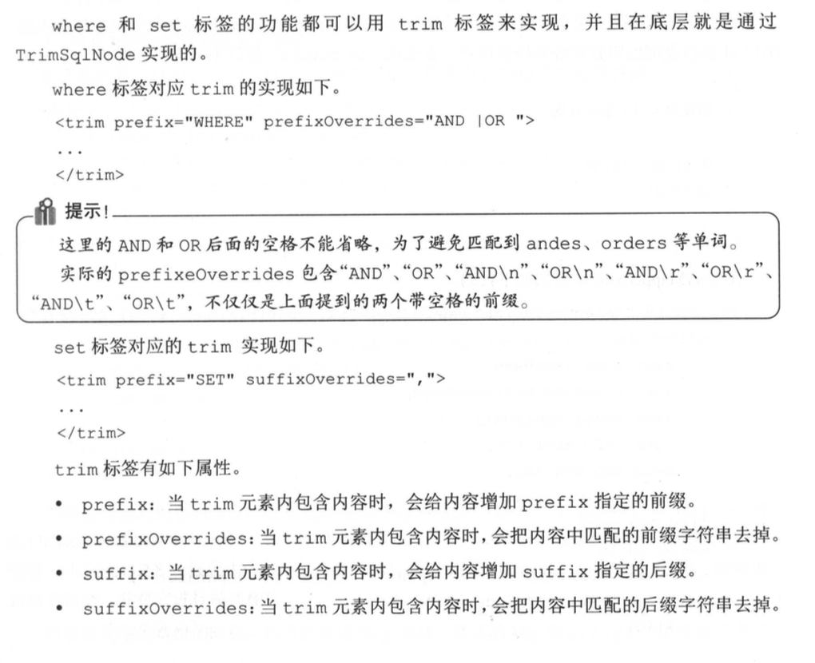

## 4.4 foreach用法

### 4.4.1 foreach 实现in集合

### 4.4.2 foreach 实现批量插入

### 4.4.3 foreach 实现动态update

在UserMapper.xml文件中添加

|  |
| --- |
| */**  * 根据用户id集合查询  *  \** ***@param*** *idList  \** ***@return*** *\*/* List<SysUser> selectByIdList(List<Long> idList);   */**  * 根据用户id数组查询  *  \** ***@param*** *idList  \** ***@return*** *\*/* List<SysUser> selectByIdList(Long[] idList);   */**  * 批量插入用户信息  *  \** ***@param*** *userList  \** ***@return*** *\*/* int insertList(List<SysUser> userList);   */**  * 通过Map更新列  *  \** ***@param*** *map  \** ***@return*** *\*/* int updateByMap(Map<String,Object> map); |

在UserMapper.xml中添加

|  |
| --- |
| <!--  foreach属性：  collection：必填，值为要迭代循环的属性名。  item：变量名，值为从迭代对象中取出的每一个值  index：索引的属性名  open：真个循环内容开头的字符串。  close：整个循环内容结尾的字符串  separator：每次循环的分隔符 --> <select id="selectByIdList" resultType="com.mybatis.book.study.model.SysUser">  select id,  user_name userName,  user_password userPassword,  user_email userEmail,  user_info userInfo,  head_img headImg,  create_time createTime  from sys_user  where id in  <foreach collection="list" open="(" close=")" separator="," item="id" index="i">  #{id}  </foreach> </select>  <insert id="insertList" useGeneratedKeys="true" keyProperty="id">  insert into sys_user (  user_name,user_password,user_email,  user_info,head_img,create_time  ) values  <foreach collection="list" item="user" separator=",">  (  #{user.userName,jdbcType=VARCHAR} ,  #{user.userPassword} ,  #{user.userEmail} ,  #{user.userInfo,jdbcType=VARCHAR} ,  #{user.headImg,jdbcType=BLOB} ,  #{user.createTime,jdbcType=TIMESTAMP}  )  </foreach> </insert>  <!--  没有添加@Param注解指定参数名，则默认是_parameter --> <update id="updateByMap" >  update sys_user  set  <foreach collection="_parameter" item="val" index="key" separator=",">  ${key} = #{val}  </foreach>  where id = #{id} </update> |

在UserMapperTest.java中

|  |
| --- |
| @Test public void testSelectByIdList() {  SqlSession sqlSession = *getSqlSession*();  try {  UserMapper userMapper = sqlSession.getMapper(UserMapper.class);  List<Long> idList = new ArrayList<>();   idList.add(1L);  idList.add(1001L);   List<SysUser> userList = userMapper.selectByIdList(idList);  *assertEquals*(2, userList.size());   } finally {  sqlSession.close();  } }  @Test public void testInsertList() {  SqlSession sqlSession = *getSqlSession*();  try {  UserMapper userMapper = sqlSession.getMapper(UserMapper.class);  List<SysUser> userList = new ArrayList<>();  for (int i = 0; i < 2; i++) {  SysUser user = new SysUser();   user.setUserName("test"+i);  user.setUserPassword("123456");  user.setUserEmail("test@mybatis.tk");  userList.add(user);  }  int result = userMapper.insertList(userList);  *assertEquals*(2,result);  for (SysUser user : userList) {  System.*out*.println(user.getId());  }  } finally {  sqlSession.rollback();  sqlSession.close();  } }  @Test public void testUpldateByMap(){  SqlSession sqlSession = *getSqlSession*();  try {  UserMapper userMapper = sqlSession.getMapper(UserMapper.class);   Map<String,Object> map = new HashMap<>();  map.put("id",1L);  map.put("user_email","test@mybatis.tk");  map.put("user_password","123456");   userMapper.updateByMap(map);   SysUser user = userMapper.selectById(1L);  *assertEquals*("test@mybatis.tk",user.getUserEmail());  }finally {  sqlSession.rollback();  sqlSession.close();   } } |

## 4.5 bind用法

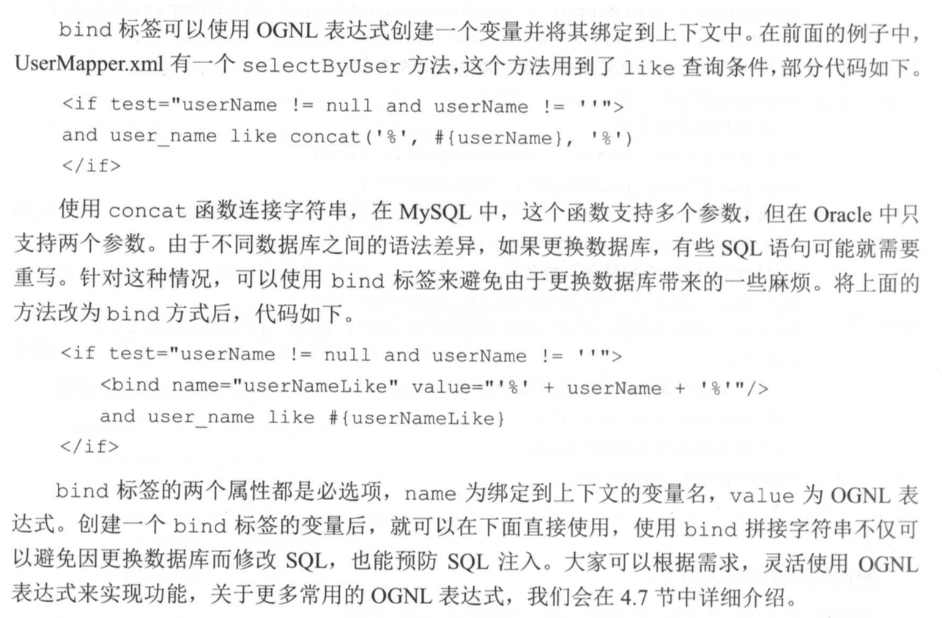

## 4.6 多数据库支持

在mybatis-config.xml文件中加入databaseIdProvider配置即可

<databaseIdProvider type=”DB_VENDOR” />

|  |
| --- |
| <select id="selectByUser" databaseId="mysql" resultType="com.mybatis.book.study.model.SysUser">  select id,  user_name userName,  user_password userPassword,  user_email userEmail,  user_info userInfo,  head_img headImg,  create_time createTime  from sys_user  <where>  <if test="userName !=null and userName != ''">  and user_name like concat('%',#{userName},'%')  </if>  <if test="userEmail != null and userEmail != ''">  and user_email = #{userEmail}  </if>  </where>  </select>    <select id="selectByUser" databaseId="oracle" resultType="com.mybatis.book.study.model.SysUser">  select id,  user_name userName,  user_password userPassword,  user_email userEmail,  user_info userInfo,  head_img headImg,  create_time createTime  from sys_user  <where>  <if test="userName !=null and userName != ''">  and user_name like '%'||#{userName}||'%'  </if>  <if test="userEmail != null and userEmail != ''">  and user_email = #{userEmail}  </if>  </where>  </select>   <!-- 这种使用方式避免了 重复-->  <select id="selectByUser" resultType="com.mybatis.book.study.model.SysUser">  select id,  user_name userName,  user_password userPassword,  user_email userEmail,  user_info userInfo,  head_img headImg,  create_time createTime  from sys_user  <where>  <if test="userName !=null and userName != ''">  <if test="_databaseId == 'mysql'">  and user_name like concat('%',#{userName},'%')  </if>  <if test="_databaseId == 'oracle'">  and user_name like '%'||#{userName}||'%'  </if>   </if>  <if test="userEmail != null and userEmail != ''">  and user_email = #{userEmail}  </if>  </where>  </select> |

## 4.7 OGNL用法

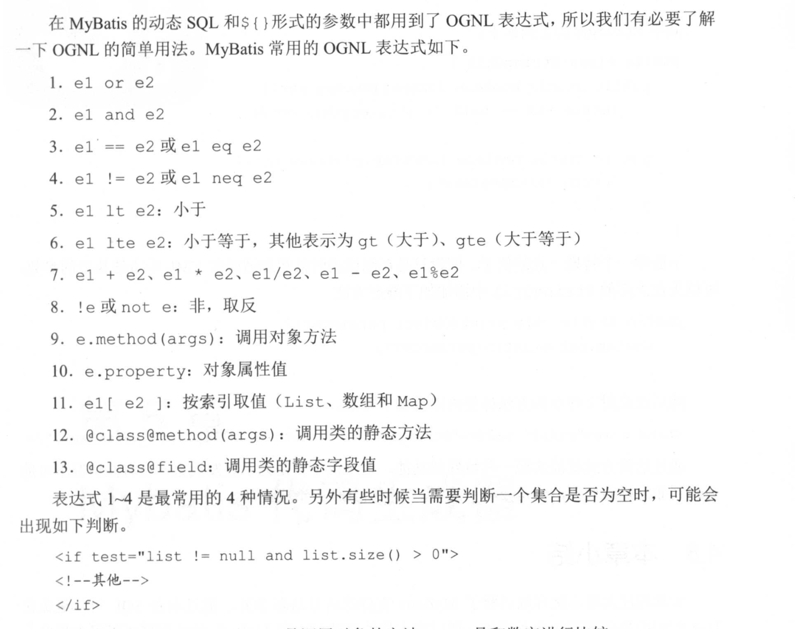

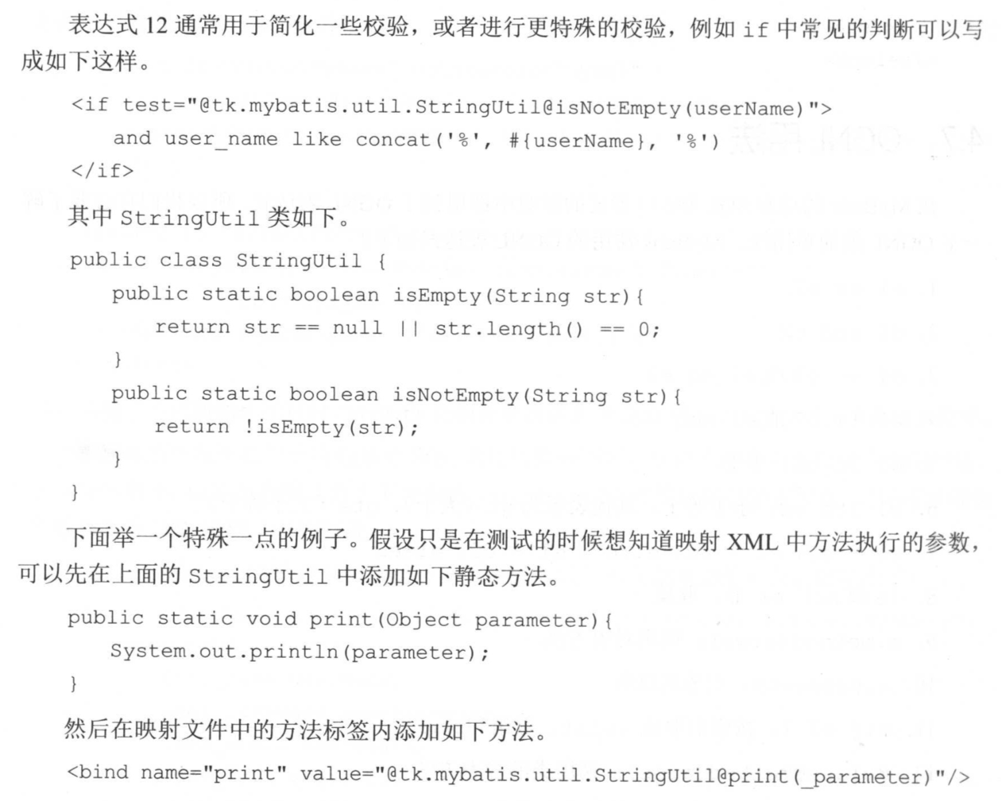

# **5 Mybatis 代码生成器**

## 5.1 XML配置详解

先看5.3章节怎么先创建一个逆向工程

context：标签至少配置一个，可以配置多个

指用于生成一组对象的环境。例如指定要连接的数据库，要生成对象的类型和要处理的数据库中的表。

属性：id，必选

defaultModelType：定义了MBG如何生成实体类。该属性有以下可选值：

(1)coditional默认值，和hierachical类似，如果一个表的主键只有一个字段，那么不会为该字段生成单独的实体类，而是会将该字段合并到基本实体类中

(2)flat：该模型值为每张表生成一个实体类。这个实体类包含表中的所有字段。这种模型最简单，推荐使用

(3)hierarchical:如果表有主见，那么该模型会产生一个单独的主键实体类，如果表还有BLOB字段，则会为表生一个包含所有单独的实体类。MBG会在所有生成的实体类之间维护一个继承关系

targetRuntime:此属性用于指定生成代码的运行时环境，可选值：Mybatis3：默认值，Mybatis3Simple:这种情况不会生成与Example相关的方法。

introspectedColumnImpl:该参数可以指定扩展org.mybatis.generator.api.Introspected Column类的实现类。

一般配置：<context id="Mysql" defaultModeType="flat">

context的子标签(有严格顺序)：

property(0个或多个)

plugin(0个或多个)

commentGenerator(0个或1个)

jdbcConnection(1个)

javaTypeResolver(0个或1个)

javaModelGenerator(1个)

sqlMapGenerator(0个或1个)

javaClientGenerator(0个或1个)

table(1个或多个)

### 5.1.1 property标签

<property>标签属性如下：

autoDelimitKeywords：

beginningDelimiter:

endingDelimiter：

以上三个属性时解决表名中间有空格的情况如(user info)

<context id=”Mysql” targetRuntime=”MyBatis3Simple“ defaultModeType=”flat”。

<property name=”autoDelimitKeywords” value=”true”/>

<property name=”beginningDelimiter” value=”`”/>

<property name=”endingDelimiter” value=”`”/>

</context>

javaFileEncoding:编码问题GBK,UTF-8

javaFormatter:不常用

xmlFormatter：不常用

### 5.1.2 plugin标签

Plugin：定义一个插件，

缓存插件全限定名称：org.mybatis.generator.plugins.CachePlugin.

该插件只有当targetRuntime为MyBatis4时，才生效。插件的可选属性

Cache_eviction

Cachee_flushInterval

Cache_readOnly

Cache_size

Cache_type

<plugin type=”org.mybatis.generator.plugins.CachePlugin”>

<property name=”cache_eviction” value=”LRU”/>

<property name=”cache_size” value=”1024”/>

</plugin>

配置这个标签后，生成的Mapper.xml文件中会增加如下的缓存相关的配置

<cache eviction=“LRU” size=”1024”>

</cache>

### 5.1.3 commentGenerator标签

commentGenerator：配置如何生成注释信息。最多可以配置一个

默认实现类：org.mybatis.generator.internal.DefaultCommentGenerator.

提供三个可选属性，需要通过property属性进行配置

suppressAllComments：阻止生成注释，默认为false

suppressDate:阻止生成的蛛丝包哈时间错，默认为false

addRemarkComments:注释是否添加数据库表的备注信息，默认为false

<commentGenerator>

<property name=”suppressDate” value=”true”/>

<property name=”addRemarkComments” value=”true“/>

</commentGenerator>

配置自己的注释生成器，

<commentGenerator type=”com.mybatis.book.study.generator.MyCommentGenerator”>

<property name=”suppressDate” value=”true”/>

<property name=”addRemarkComments” value=”true”/>

</commentGenerator>

### 5.1.4 jdbcConnection标签

指定MBG要连接的数据库信息，该标签必选，并且只能有一个。

配置该标签需要注意，如果JDBC驱动不在classpath下，就要通过classPathEntry标签引入jar包。

<jdbcConnection driverClass=”com.mysql.jdbc.Driver” connectionURL=”jdbc:mysql://localhost:3306/mybatis” userId=”root” password=“”>

</jdbcConnection>

oracle配置

<jdbcConnection driverClass=“oracle.jdbc.driver.OracleDriver” connectionURL=”jdbc:oracle:thin:@//localhost:1521/orcl” userId=”mybatis” password=”mybatis”

<property name=”remarksReporting” value=”true”/>

</jdbcConnection>

### 5.1.5 javaTypeResolver标签

该标签的配置用来指定JDBC类型和Java类型如何装换，最多配置一个

该属性还有一个可以配置的property标签，可以配置的属性为forceBIgDecimals，该属性可以控制是否强制将DECIMAL和NUMERIC类型JDBC字段转换为Java类型的java.math.BigDecimal，默认值为false。

默认情况下的装换规则如下。

如果精度>0或者长度>18，就使用java.math.BigDecimal。

如果精度=0并且10<=长度<=18，就使用java.lang.Long。

如果进度=0并且5<=长度<=9,就使用java.lang.Integer。

如果精度=0并且长度<5,就使用java.lang.Short.

如果将forceBigDecimals设置为true，就一定会使用java.math.BigDecimal类型

javaTypeResovler标签配置如下：

<javaTypeResolver>

<property name=”forceBigDevimals” value=”false” />

</javaTypeResolver>

### 5.1.6 javaModelGenerator标签

该标签用来控制生成的实体类，根据context标签中配置的defaultModelType属性值的不同，一个表可能会对应生成多个不同的实体类。

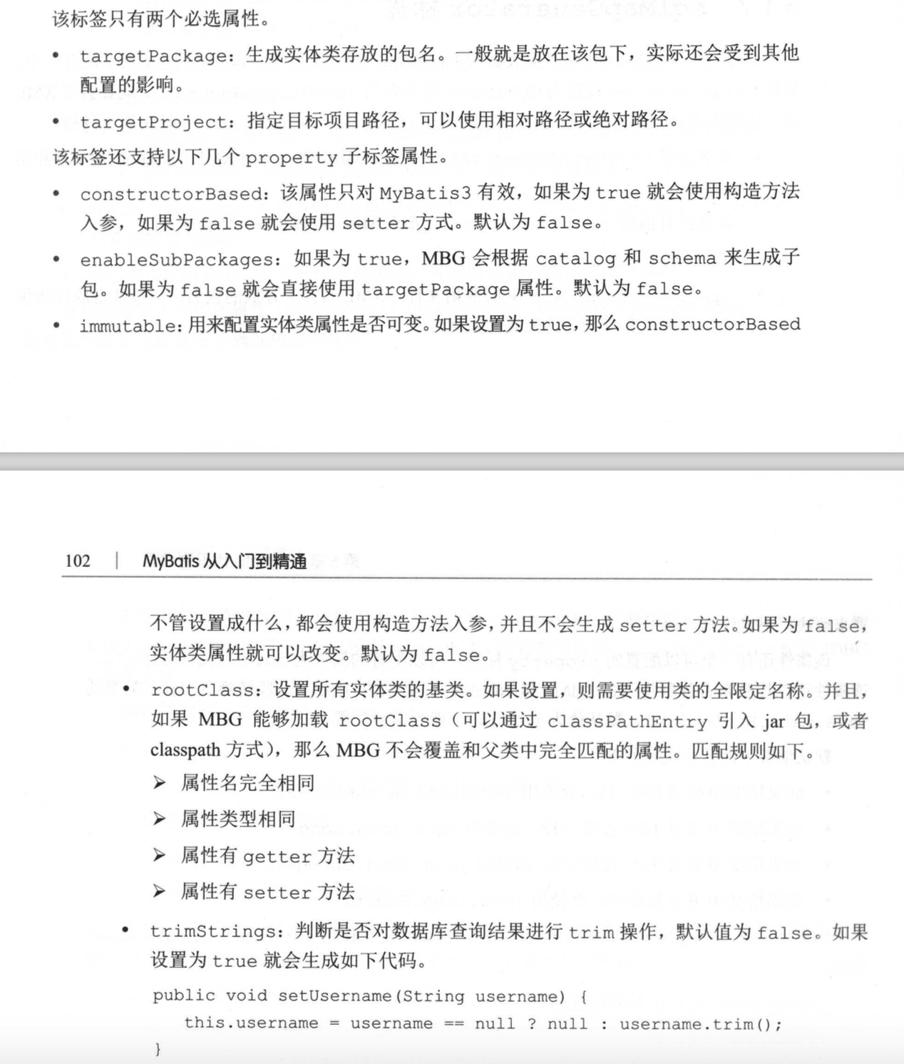

<javaModelGenerator targetPackage=”test.model” targetProject=“src\main\java”>

<property name=”enableSubPackages“ value=”false”/>

<property name=”trimStrings“ value=”false“>

</javaModelGenerator>

### 5.1.7 sqlMapGenerator标签

用于配置SQL映射生成器(Mapper.xml文件)属性，该标签可选，最多配置一个。

当javaClientGenerator配置需要xml时，该标签才必须配置一个。如果没有配置javaClientGenerator，则使用一下规则：

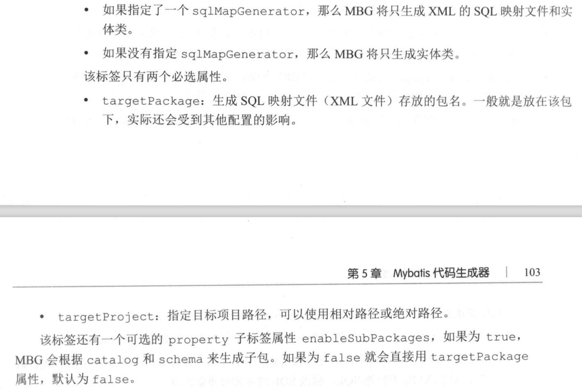

<sqlMapGerator targetPackage=”test.xml” targetProject=”E:\MyProject\src\main\reesources”>

<property name=”enableSubPackages” value=”false” />

</sqlMapGenerator>

### 5.1.8 javaClientGenerator标签

该标签有以下3个属性，该标签可选，最多配置一个。该标签不配置，就不会生成Mapper接口

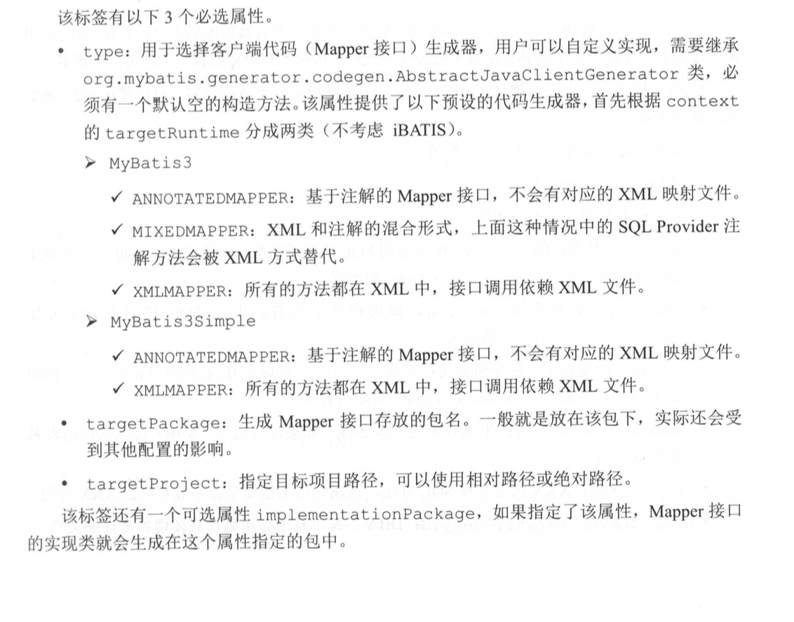

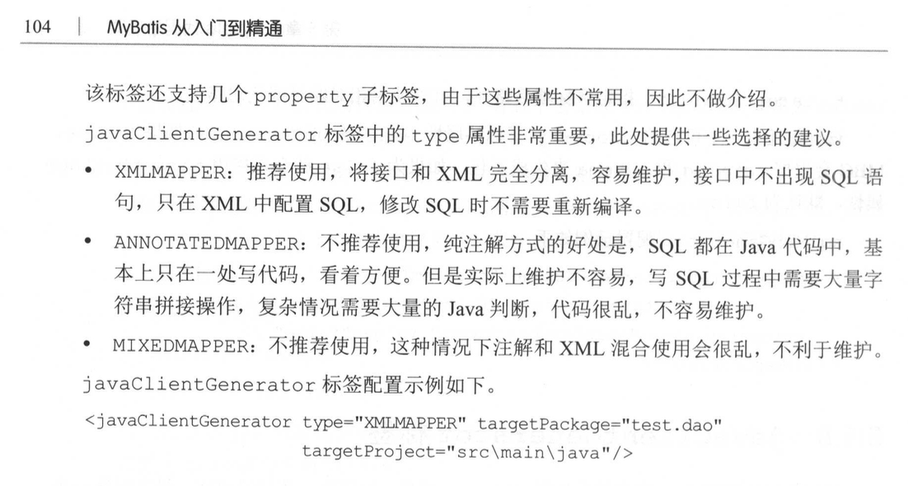

### 5.1.9 table标签

table是一个最重要的标签

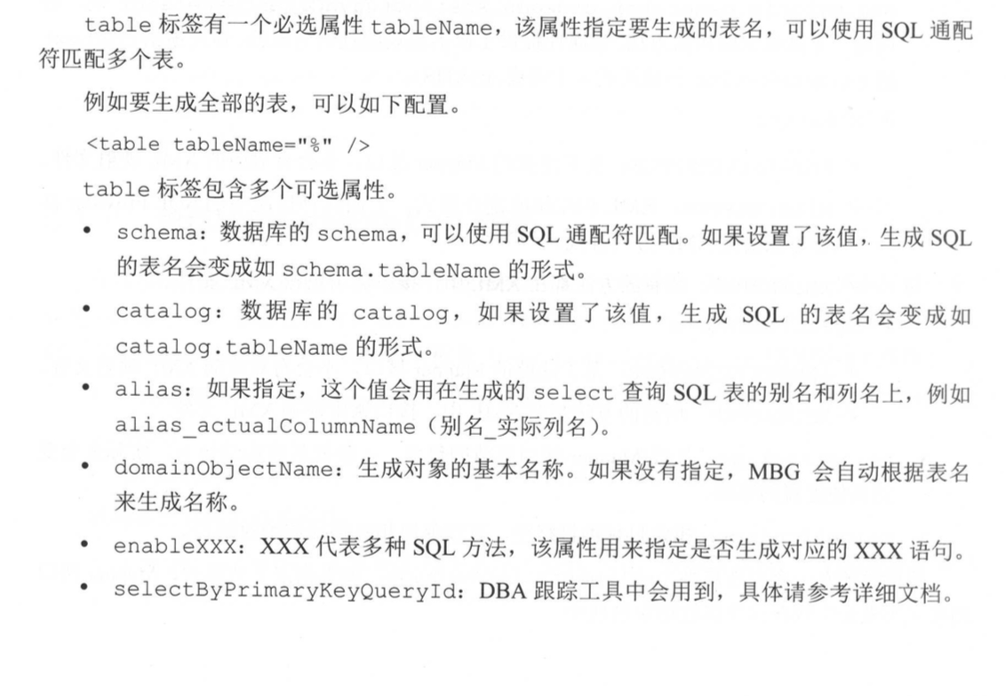

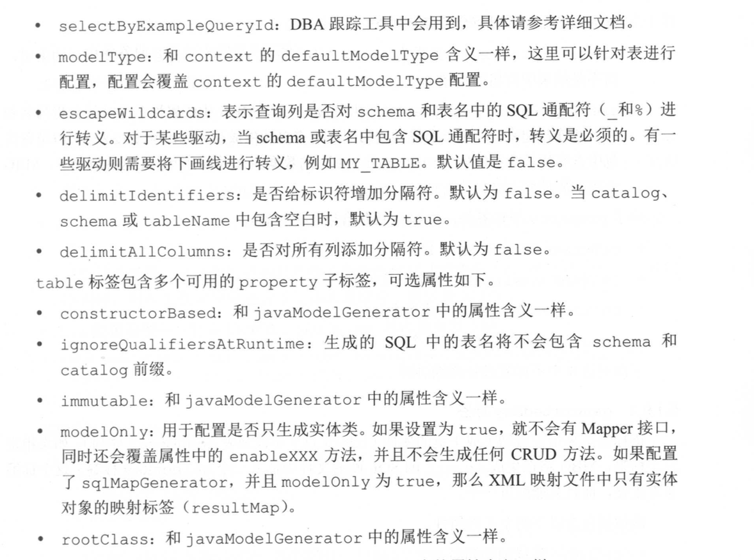

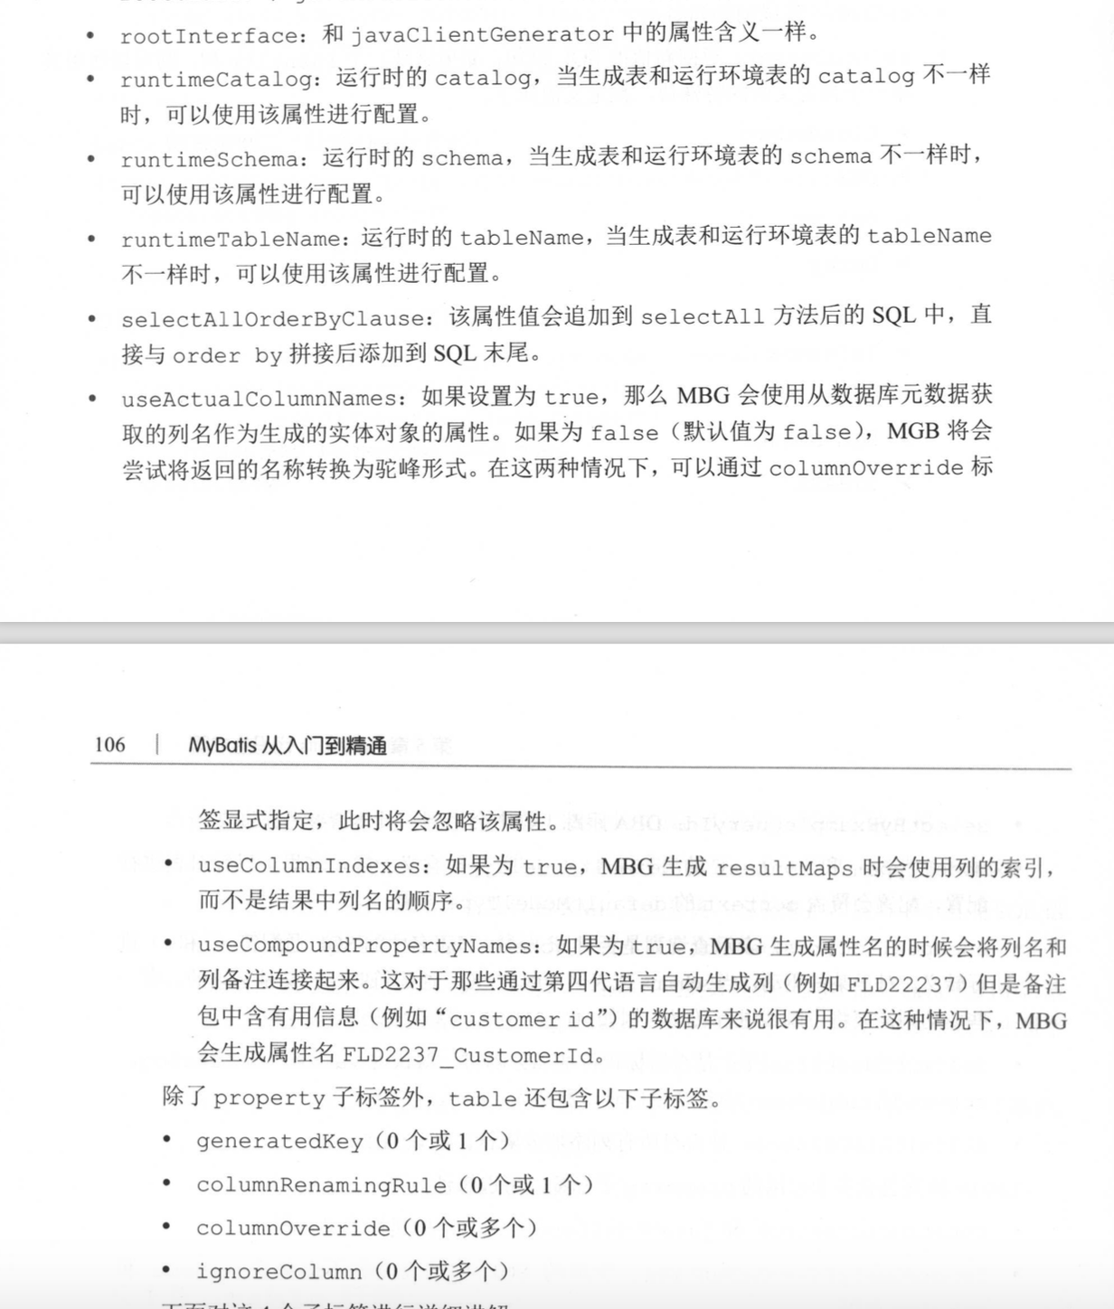

**5.1.9.1 generateKey标签**

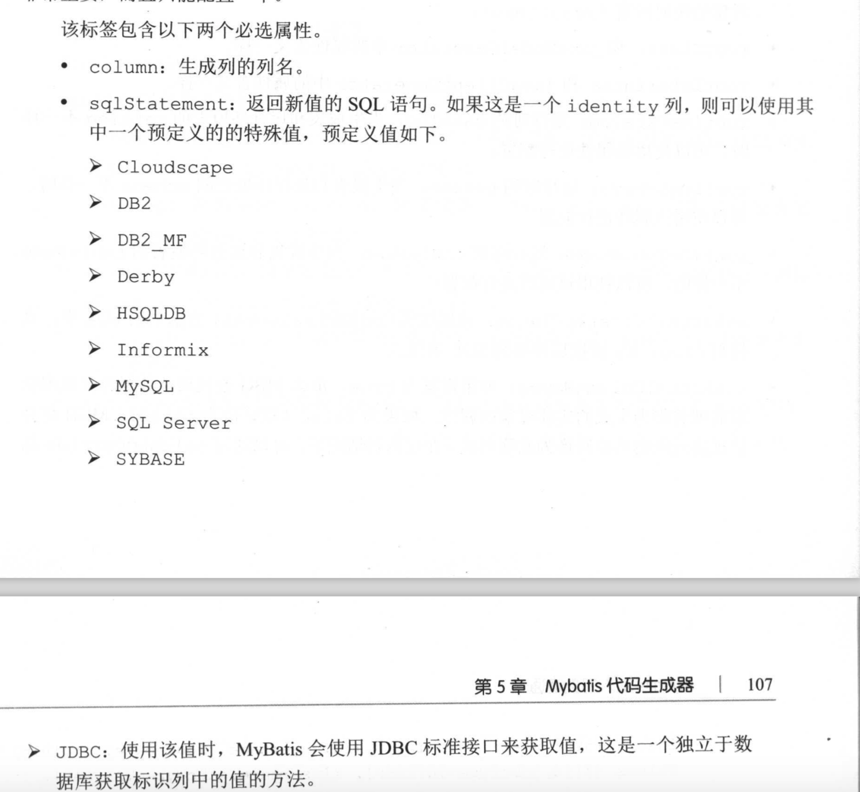

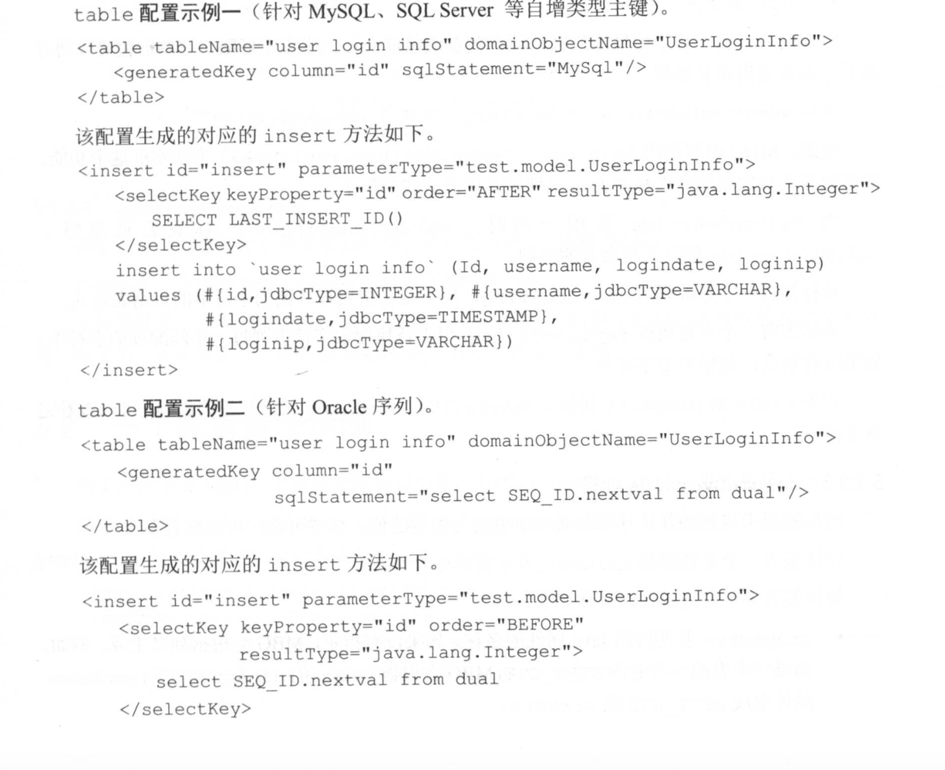

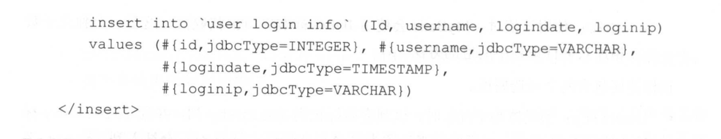

**5.1.9.2 columnRenamingRule标签**

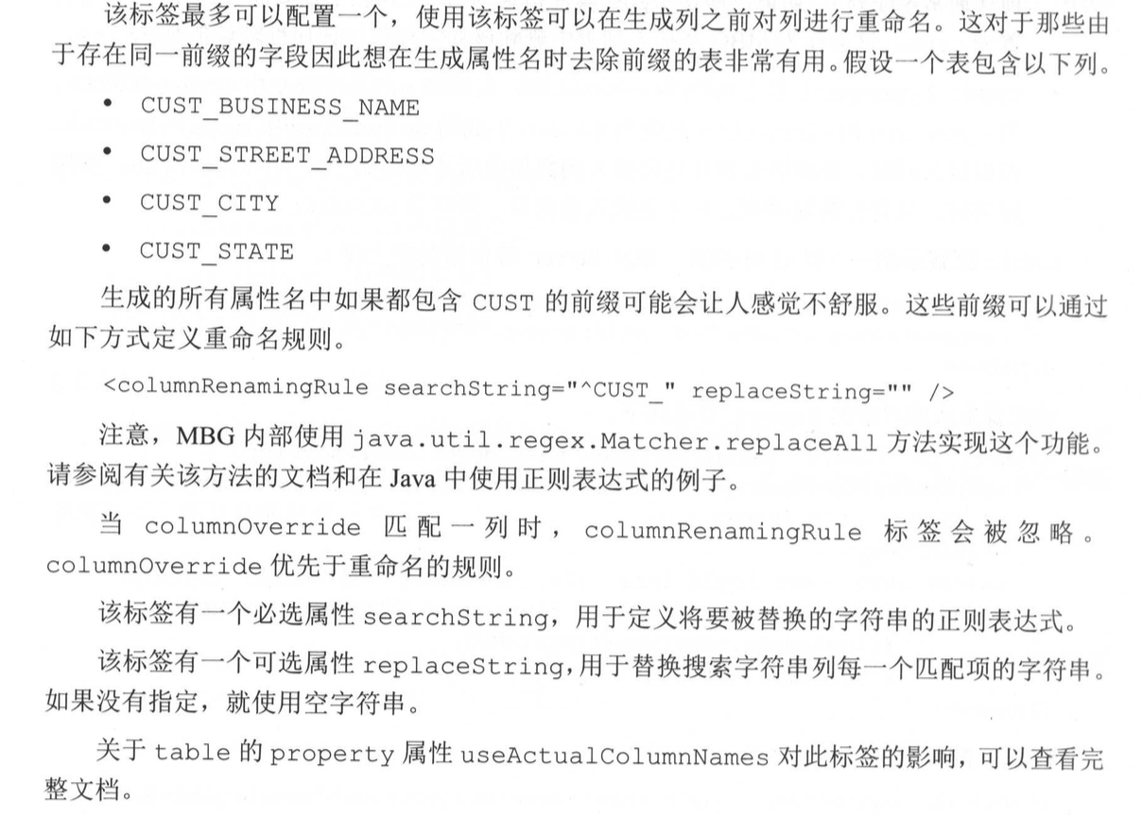

**5.1.9.3 columnOverride标签**

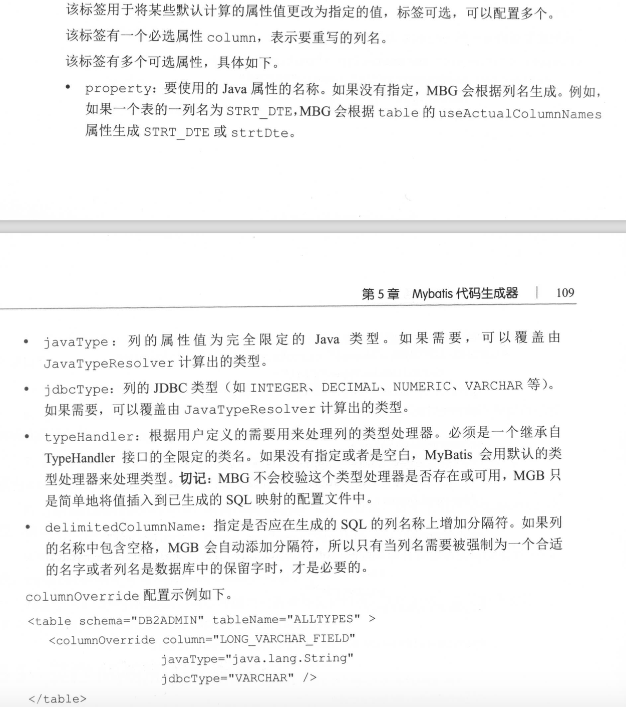

**5.1.9.4 ignoreColumn标签**



## 5.2 一个配置参考示例

|  |
| --- |
| <?xml version="1.0" encoding="UTF-8"?> <!DOCTYPE generatorConfiguration PUBLIC "-//mybatis.org//DTD MyBatis Generator Configuration 1.0//EN"  "http://mybatis.org/dtd/mybatis-generator-config_1_0.dtd"> <generatorConfiguration>   <!--  properties： 用于指定一个需要在配置中解析使用的外部属性文件  属性: resource和url  resource：指定classpath下的属性文件，类似com/myproject/generatorConfig.properties  url:指定文件系统上的特定位置，例如file://C:/myfolder/generatorConfig.properties    --> <!-- <properties>-->   <!-- </properties>-->   <!-- classPathEntry标签最常见的用法是通过属性location指定驱动的路径-->  <!-- <classPathEntry location="/Users/zs/.m2/repository/mysql/mysql-connector-java/5.1.38/mysql-connector-java-5.1.38.jar"/>-->    <!--  context：标签至少配置一个，可以配置多个  指用于生成一组对象的环境。例如指定要连接的数据库，要生成对象的类型和要处理的数据库中的表。  属性：id，必选  defaultModelType：定义了MBG如何生成实体类。该属性有以下可选值：  (1)coditional默认值，和hierachical类似，如果一个表的主键只有一个字段，那么不会为该字段生成单独的实体类，而是会将该字段合并到基本实体类中  (2)flat：该模型值为每张表生成一个实体类。这个实体类包含表中的所有字段。这种模型最简单，推荐使用  (3)hierarchical:如果表有主见，那么该模型会产生一个单独的主键实体类，如果表还有BLOB字段，则会为表生一个包含所有单独的实体类。MBG会在所有生成的实体类之间维护一个继承关系  targetRuntime:此属性用于指定生成代码的运行时环境，可选值：Mybatis3：默认值，Mybatis3Simple:这种情况不会生成与Example相关的方法。  introspectedColumnImpl:该参数可以指定扩展org.mybatis.generator.api.Introspected Column类的实现类。  一般配置：<context id="Mysql" defaultModeType="flat">  context的子标签(有严格顺序)：  property(0个或多个)  plugin(0个或多个)  commentGenerator(0个或1个)  jdbcConnection(1个)  javaTypeResolver(0个或1个)  javaModelGenerator(1个)  sqlMapGenerator(0个或1个)  javaClientGenerator(0个或1个)  table(1个或多个)  -->  <context id="MysqlContext" targetRuntime="MyBatis3">  <property name="beginningDelimiter" value="`"/>  <property name="endingDelimiter" value="`"/>   <commentGenerator>  <property name="suppressDate" value="true"/>  <property name="addRemarkComments" value="true"/>  </commentGenerator>   <jdbcConnection driverClass="com.mysql.jdbc.Driver" connectionURL="jdbc:mysql://localhost:3306/mybatis-study" userId="root" password="mysql"></jdbcConnection>     <javaModelGenerator targetPackage="com.mybatis.book.study.model" targetProject="book1-mybatis-generator/src/main/java">  <property name="trimStrings" value="true"/>  </javaModelGenerator>  <sqlMapGenerator targetPackage="mappers" targetProject="book1-mybatis-generator/src/main/resources"></sqlMapGenerator>    <javaClientGenerator type="XMLMAPPER" targetPackage="com.mybatis.book.study.mapper" targetProject="book1-mybatis-generator/src/main/java"/>  <table tableName="sys_user">  <generatedKey column="id" sqlStatement="MySql"/>  </table>  </context> </generatorConfiguration> |

## 5.3 运行MyBatis Generator

新建项目

book1-mybatis-generator

├── pom.xml

└── src

└── main

├── java

│   └── com

│   └── mybatis

│   └── book

│   └── study

│   ├── generator

│   │   ├── Generator.java

│   │   └── MyCommentGenerator.java

│   ├── mapper

│   │   └── SysUserMapper.java

│   └── model

│   ├── SysUser.java

│   ├── SysUserExample.java

│   └── SysUserWithBLOBs.java

└── resources

├── generator

│   └── generatorConfig.xml

└── mappers

└── SysUserMapper.xml

pom.xml

|  |
| --- |
| <?xml version="1.0" encoding="UTF-8"?> <project xmlns="http://maven.apache.org/POM/4.0.0"  xmlns:xsi="http://www.w3.org/2001/XMLSchema-instance"  xsi:schemaLocation="http://maven.apache.org/POM/4.0.0 http://maven.apache.org/xsd/maven-4.0.0.xsd">  <modelVersion>4.0.0</modelVersion>   <groupId>com.mybatis.book.study</groupId>  <artifactId>book1-mybatis-generator</artifactId>  <version>1.0-SNAPSHOT</version>   <dependencies>  <dependency>  <groupId>org.mybatis.generator</groupId>  <artifactId>mybatis-generator-core</artifactId>  <version>1.3.3</version>  </dependency>   <dependency>  <groupId>mysql</groupId>  <artifactId>mysql-connector-java</artifactId>  <version>5.1.32</version>  </dependency>   <dependency>  <groupId>org.mybatis</groupId>  <artifactId>mybatis</artifactId>  <version>3.3.1</version>  </dependency>  </dependencies>  </project> |

Generator.java

|  |
| --- |
| package com.mybatis.book.study.generator;  import org.mybatis.generator.api.MyBatisGenerator; import org.mybatis.generator.config.Configuration; import org.mybatis.generator.config.xml.ConfigurationParser; import org.mybatis.generator.exception.XMLParserException; import org.mybatis.generator.internal.DefaultShellCallback;  import java.io.IOException; import java.io.InputStream; import java.util.ArrayList; import java.util.List;  public class Generator {  public static void main(String[] args) throws Exception {   // MBG执行过程中的警告信息  List<String> warnings = new ArrayList<String>();   // 当生成的代码重复时，覆盖原代码  boolean overwrite = true;  // generator/generatorConfig.xml  InputStream is = Generator.class.getResourceAsStream("/generator/generatorConfig.xml");   ConfigurationParser cp = new ConfigurationParser(warnings);  Configuration config = cp.parseConfiguration(is);   is.close();   DefaultShellCallback callback = new DefaultShellCallback(overwrite);   // 创建MBG  MyBatisGenerator myBatisGenerator = new MyBatisGenerator(config, callback, warnings);  // 执行生成代码  myBatisGenerator.generate(null);  // 输出警告信息  for (String warning : warnings) {  System.*out*.println(warning);  }     } } |

运行该文件，会生成相应的model mapper接口 mapper配置等文件

## 5.3.1 使用Java编写代码运行

### 5.3.2 从命令提示符运行

### 5.3.3 使用Maven Plugin运行

### 5.3.4 使用Eclipse插件运行

# **6 Mybatis 高级查询**

## 6.1 高级结果映射

### 6.1.1一对一映射

**6.1.1.1 使用自动映射处理一对一关系**

在SysUser中增加SysRole字段

private SysRole role;

public SysRole getRole() {  
 return role;  
}  
  
public void setRole(SysRole role) {  
 this.role = role;  
}

在UserMapper.xml中增加如下方法：

|  |
| --- |
| <select id="selectUserAndRoleById" resultType="com.mybatis.book.study.model.SysUser">  select  u.id,  u.user_name userName,  u.user_password userPassword,  u.user_email userEmail,  u.user_info userInfo,  u.head_img headImg,  u.create_time createTime,  r.id "role.id",  r.role_name "role.roleName",  r.enabled "role.enabled",  r.create_by "role.createBy",  r.create_time "role.createTime"  from sys_user u  inner join sys_user_role ur on u.id = ur.user_id  inner join sys_role r on ur.role_id = r.id  where u.id = #{id} </select>  列的别名使用SysUser中字段role.属性 |

在UserMapper.java中增加方法

|  |
| --- |
| */**  * 根据用户id获取用户信息和用户的角色信息：根据(字段.字段：role.roleName)自动映射  *  \** ***@param*** *id  \** ***@return*** *\*/* SysUser selectUserAndRoleById(Long id); |

在UserMapperTest.java中增加方法

|  |
| --- |
| @Test public void testSelectUserAndRoleById(){  SqlSession sqlSession = *getSqlSession*();   try {  UserMapper userMapper = sqlSession.getMapper(UserMapper.class);  SysUser user = userMapper.selectUserAndRoleById(1001L);   *assertNotNull*(user);  *assertNotNull*(user.getRole());  }finally {  sqlSession.close();  } } |

**6.1.1.2 使用resultMap处理一对一关系**

在UserMapper.xml中增加如下：

|  |
| --- |
| <resultMap id="userRoleMap" type="com.mybatis.book.study.model.SysUser">   <id property="id" column="id"/>  <result property="userName" column="user_name"/>  <result property="userPassword" column="user_password"/>  <result property="userEmail" column="user_email"/>  <result property="userInfo" column="user_info"/>  <result property="headImg" column="head_img" jdbcType="BLOB"/>  <result property="createTime" column="create_time" jdbcType="TIMESTAMP"/>   <!-- role相关属性-->  <result property="role.id" column="role_id"/>  <result property="role.roleName" column="role_name"/>  <result property="role.enabled" column="enabled"/>  <result property="role.createBy" column="create_by"/>  <result property="role.createTime" column="role_create_time" jdbcType="TIMESTAMP"/>  </resultMap>  <select id="selectUserAndRoleById2" resultMap="userRoleMap">  select  u.id,  u.user_name userName,  u.user_password userPassword,  u.user_email userEmail,  u.user_info userInfo,  u.head_img headImg,  u.create_time createTime,  r.id role_id,  r.role_name ,  r.enabled ,  r.create_by,  r.create_time role_create_time  from sys_user u  inner join sys_user_role ur on u.id = ur.user_id  inner join sys_role r on ur.role_id = r.id  where u.id = #{id} </select> |

在UserMapper.java中增加方法

|  |
| --- |
| */**  * 根据用户id获取用户信息和用户的角色信息  *  \** ***@param*** *id  \** ***@return*** *\*/* SysUser selectUserAndRoleById2(Long id); |

在UserMapperTest.java中

|  |
| --- |
| @Test public void testSelectUserAndRoleById2(){  SqlSession sqlSession = *getSqlSession*();   try {  UserMapper userMapper = sqlSession.getMapper(UserMapper.class);  SysUser user = userMapper.selectUserAndRoleById2(1001L);   *assertNotNull*(user);  *assertNotNull*(user.getRole());  }finally {  sqlSession.close();  } } |

userRoleMap中SysUser的映射可以用extends=“userMap”替代：将userRoleMap修改如下

|  |
| --- |
| <resultMap id="userRoleMap" type="com.mybatis.book.study.model.SysUser" extends="userMap">   <!-- role相关属性-->  <result property="role.id" column="role_id"/>  <result property="role.roleName" column="role_name"/>  <result property="role.enabled" column="enabled"/>  <result property="role.createBy" column="create_by"/>  <result property="role.createTime" column="role_create_time" jdbcType="TIMESTAMP"/>  </resultMap> |

**6.1.1.3 使用resultMap的association标签配置一对一映射**

继续修改userRoleMap

|  |
| --- |
| <resultMap id="userRoleMap" type="com.mybatis.book.study.model.SysUser" extends="userMap">  <association property="role" columnPrefix="role_" javaType="com.mybatis.book.study.model.SysRole">  <result property="id" column="id"/>  <result property="roleName" column="role_name"/>  <result property="enabled" column="enabled"/>  <result property="createBy" column="create_by"/>  <result property="createTime" column="create_time" jdbcType="TIMESTAMP"/>  </association> </resultMap>    <!--  userRoleMap: association标签 配置columnPrefix="role_"前缀，所以列别名需要加role_前缀 --> <select id="selectUserAndRoleById3" resultMap="userRoleMap">  select  u.id,  u.user_name userName,  u.user_password userPassword,  u.user_email userEmail,  u.user_info userInfo,  u.head_img headImg,  u.create_time createTime,  r.id role_id,  r.role_name role_role_name,  r.enabled role_enabled,  r.create_by role_create_by,  r.create_time role_create_time  from sys_user u  inner join sys_user_role ur on u.id = ur.user_id  inner join sys_role r on ur.role_id = r.id  where u.id = #{id} </select> |

UserMapper.java

|  |
| --- |
| */**  * 根据用户id获取用户信息和用户的角色信息：association  *  \** ***@param*** *id  \** ***@return*** *\*/* SysUser selectUserAndRoleById3(Long id); |

UserMapperTest.java

|  |
| --- |
| @Test public void testSelectUserAndRoleById3(){  SqlSession sqlSession = *getSqlSession*();   try {  UserMapper userMapper = sqlSession.getMapper(UserMapper.class);  SysUser user = userMapper.selectUserAndRoleById3(1001L);   *assertNotNull*(user);  *assertNotNull*(user.getRole());  }finally {  sqlSession.close();  } } |

还可以对userRoleMap进行优化，将SysRole做成resultMap映射,然后通过association的标签属性resultMap=”roleMap” 赋值引用

第一种在UserMapper.xml做

|  |
| --- |
| <resultMap id="roleMap" type="com.mybatis.book.study.model.SysRole">  <id property="id" column="id"/>  <result property="roleName" column="role_name"/>  <result property="enabled" column="enabled"/>  <result property="createBy" column="create_by"/>  <result property="createTime" column="create_time" jdbcType="TIMESTAMP"/> </resultMap>  <resultMap id="userRoleMap" type="com.mybatis.book.study.model.SysUser" extends="userMap">  <association property="role" columnPrefix="role_" resultMap="roleMap">  </association> </resultMap> |

第二种将roleMap写在RoleMapper.xml:推荐这种，更加合理

在RoleMapper.xml

|  |
| --- |
| <resultMap id="roleMap" type="com.mybatis.book.study.model.SysRole">  <id property="id" column="id"/>  <result property="roleName" column="role_name"/>  <result property="enabled" column="enabled"/>  <result property="createBy" column="create_by"/>  <result property="createTime" column="create_time" jdbcType="TIMESTAMP"/> </resultMap> |

在UserMapper.xml中调整userRoleMap的accociation的属性resultMap=”com.mybatis.book.study.mapper.RoleMapper.roleMap” ，加上命名空间com.mybatis.book.study.mapper.RoleMapper

|  |
| --- |
| <resultMap id="userRoleMap" type="com.mybatis.book.study.model.SysUser" extends="userMap">  <association property="role" columnPrefix="role_" resultMap="com.mybatis.book.study.mapper.RoleMapper.roleMap">  </association> </resultMap> |

**6.1.1.4 association标签的嵌套查询**

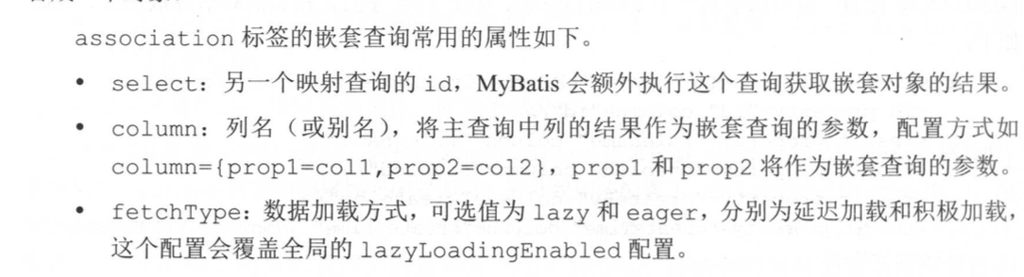

在mybatis-config.xml中做懒加载配置

|  |
| --- |
| <!-- 是否延迟加载：false懒加载--> <setting name="aggressiveLazyLoading" value="false"/> |

在UserMapper.xml中做如下修改：

|  |
| --- |
| <resultMap id="userRoleMapSelect" type="com.mybatis.book.study.model.SysUser" extends="userMap">  <association property="role" fetchType="lazy" column="{id=role_id}"  select="com.mybatis.book.study.mapper.RoleMapper.selectRoleById"></association> </resultMap>  <select id="selectUserAndRoleByIdSelect" resultMap="userRoleMapSelect">  select  u.id,  u.user_name userName,  u.user_password userPassword,  u.user_email userEmail,  u.user_info userInfo,  u.head_img headImg,  u.create_time createTime,  ur.role_id  from sys_user u  inner join sys_user_role ur on u.id = ur.user_id  where u.id = #{id} </select> |

在UserMapper.java中增加方法

|  |
| --- |
| */**  * 根据id获取用户信息和角色信息：association嵌套查询  *  \** ***@param*** *id  \** ***@return*** *\*/* SysUser selectUserAndRoleByIdSelect(Long id); |

在UserMapperTest.java中

|  |
| --- |
| @Test  public void testSelectUserAndRoleByIdSelect(){  SqlSession sqlSession = *getSqlSession*();   try {  // 查询了两次，分别先是userMapper.selectById 后是roleMapper.selectRoleById  UserMapper userMapper = sqlSession.getMapper(UserMapper.class);  SysUser user = userMapper.selectUserAndRoleByIdSelect(1001L);   */**  * 当在mybatis-config.xml中配置拦截在时，<setting name="aggressiveLazyLoading" value="false"/> ，  * 且resultMap的association标签配置fetchType="Lazy"时，会使用懒加载，即user.getRole()时，才会发送sql去查询role信息  *  */* // assertNotNull(user);  */**  * 懒加载配置的情况下：调用equals,clone,hashCode,toString方法，也会触发积极加载，  * 通过lazyLoadTriggerMethods可以配置方法。  */* System.*out*.println(user.toString()); // assertNotNull(user.getRole());  }finally {  sqlSession.close();  }  } |

### 6.1.2一对多映射

**6.1.2.1 collection集合的嵌套结果映射**

在SysUser中增加 集合roleList

|  |
| --- |
| private List<SysRole> roleList;  public List<SysRole> getRoleList() {  return roleList; }  public void setRoleList(List<SysRole> roleList) {  this.roleList = roleList; } |

在UserMapper.xml中

|  |
| --- |
| <resultMap id="userRoleListMap" extends="userMap" type="com.mybatis.book.study.model.SysUser">  <!-- <id property="id" column="id"/>-->  <!-- <result property="userName" column="user_name"/>-->  <!-- <result property="userPassword" column="user_password"/>-->  <!-- <result property="userEmail" column="user_email"/>-->  <!-- <result property="userInfo" column="user_info"/>-->  <!-- <result property="headImg" column="head_img" jdbcType="BLOB"/>-->  <!-- <result property="createTime" column="create_time" jdbcType="TIMESTAMP"/>-->   <!-- <collection property="roleList" columnPrefix="role_" javaType="com.mybatis.book.study.model.SysRole">-->  <!-- <id property="id" column="id"/>-->  <!-- <result property="roleName" column="role_name"/>-->  <!-- <result property="enabled" column="enabled"/>-->  <!-- <result property="createBy" column="create_by"/>-->  <!-- <result property="createTime" column="create_time" jdbcType="TIMESTAMP"/>-->  <!-- </collection>-->   <collection property="roleList" columnPrefix="role_"  resultMap="com.mybatis.book.study.mapper.RoleMapper.rolePrivilegeListMap"/>  </resultMap>  <select id="selectAllUserAndRoles" resultMap="userRoleListMap">  select  u.id,  u.user_name ,  u.user_password ,  u.user_email ,  u.user_info ,  u.head_img ,  u.create_time ,  r.id role_id,  r.role_name role_role_name,  r.enabled role_enabled,  r.create_by role_create_by,  r.create_time role_create_time  from sys_user u  inner join sys_user_role ur on u.id = ur.user_id  inner join sys_role r on ur.role_id = r.id </select> |

在UserMapper.java

|  |
| --- |
| */**  * 获取所有的用户以及对应的所有角色  *  \** ***@return*** *\*/* List<SysUser> selectAllUserAndRoles(); |

在UserMapperTest.xml

|  |
| --- |
| @Test public void testSelectAllUserAndRoles() {  SqlSession sqlSession = *getSqlSession*();   try {  UserMapper userMapper = sqlSession.getMapper(UserMapper.class);  List<SysUser> userList = userMapper.selectAllUserAndRoles();   System.*out*.println("用户数：" + userList.size());   for (SysUser user : userList) {  System.*out*.println("用户名：" + user.getUserName());  for (SysRole sysRole : user.getRoleList()) {  System.*out*.println("角色名：" + sysRole.getRoleName());  }  }  */**  * DEBUG [main] - ==> Preparing: select u.id, u.user_name , u.user_password , u.user_email , u.user_info , u.head_img , u.create_time , r.id role_id, r.role_name role_role_name, r.enabled role_enabled, r.create_by role_create_by, r.create_time role_create_time from sys_user u inner join sys_user_role ur on u.id = ur.user_id inner join sys_role r on ur.role_id = r.id  * DEBUG [main] - ==> Parameters:  * TRACE [main] - <== Columns: id, user_name, user_password, user_email, user_info, head_img, create_time, role_id, role_role_name, role_enabled, role_create_by, role_create_time  * TRACE [main] - <== Row: 1, admin, 123456, admin@mybatis.tk, <<BLOB>>, <<BLOB>>, 2019-10-25 16:00:00.0, 1, 管理员, 1, 1, 2019-10-25 16:00:00.0  * TRACE [main] - <== Row: 1, admin, 123456, admin@mybatis.tk, <<BLOB>>, <<BLOB>>, 2019-10-25 16:00:00.0, 2, 普通用户, 1, 1, 2019-10-25 16:00:00.0  * TRACE [main] - <== Row: 1001, test, 123456, test@mybatis.tk, <<BLOB>>, <<BLOB>>, 2019-10-25 16:00:00.0, 2, 普通用户, 1, 1, 2019-10-25 16:00:00.0  * DEBUG [main] - <== Total: 3  * 用户数：2  * 用户名：admin  * 角色名：管理员  * 角色名：普通用户  * 用户名：test  * 角色名：普通用户  *  *  * 查询出来 Total: 3 是3条，但是 输出结果是2条，原因是mybatis会根据主键进行合并操作，主键相同的则进行合并  *  */* } finally {  sqlSession.close();  } } |

在PrivilegeMapper.xml配置

|  |
| --- |
| <resultMap id="privilegeMap" type="com.mybatis.book.study.model.SysPrivilege">  <id property="id" column="id"/>  <result property="privilegeName" column="privilege_name"/>  <result property="privilegeUrl" column="privilege_url"/> </resultMap> |

在SysRole中增加privilegeList属性

|  |
| --- |
| private List<SysPrivilege> privilegeList;  public List<SysPrivilege> getPrivilegeList() {  return privilegeList; }  public void setPrivilegeList(List<SysPrivilege> privilegeList) {  this.privilegeList = privilegeList; } |

在RoleMapper.xml文件

|  |
| --- |
| <!-- 带有权限列表的resultMap--> <resultMap id="rolePrivilegeListMap" extends="roleMap" type="com.mybatis.book.study.model.SysRole">  <collection property="privilegeList" columnPrefix="privilege_"  resultMap="com.mybatis.book.study.mapper.PrivilegeMapper.privilegeMap"/> </resultMap> |

在UserMapper.xml中

|  |
| --- |
| <select id="selectAllUserAndRolesAndPrivileges" resultMap="userRoleListMap">  select  u.id,  u.user_name ,  u.user_password ,  u.user_email ,  u.user_info ,  u.head_img ,  u.create_time ,  r.id role_id,  r.role_name role_role_name,  r.enabled role_enabled,  r.create_by role_create_by,  r.create_time role_create_time,  p.id role_privilege_id,  p.privilege_name role_privilege_privilege_name,  p.privilege_url role_privilege_privilege_url  from sys_user u  inner join sys_user_role ur on u.id = ur.user_id  inner join sys_role r on ur.role_id = r.id  inner join sys_role_privilege rp on rp.role_id = r.id  inner join sys_privilege p on p.id = rp.privilege_id </select> |

在UserMapper.java

|  |
| --- |
| */**  * 获取所有的用户以及对应的所有角色,以及角色拥有的所有权限  *  \** ***@return*** *\*/* List<SysUser> selectAllUserAndRolesAndPrivileges(); |

在UserMapperTest.java

|  |
| --- |
| @Test public void testSelectAllUserAndRolesAndPrivileges() {  SqlSession sqlSession = *getSqlSession*();   try {  UserMapper userMapper = sqlSession.getMapper(UserMapper.class);  List<SysUser> userList = userMapper.selectAllUserAndRolesAndPrivileges();   System.*out*.println("用户数：" + userList.size());  for (SysUser user : userList) {  System.*out*.println("用户名：" + user.getUserName());  for (SysRole sysRole : user.getRoleList()) {  System.*out*.println("角色名：" + sysRole.getRoleName());  for (SysPrivilege sysPrivilege : sysRole.getPrivilegeList()) {  System.*out*.println("权限名：" + sysPrivilege.getPrivilegeName());  }  }  }  } finally {  sqlSession.close();  } } |

**6.1.2.2 collection集合的嵌套查询**

在PrivilegeMapper.xml中

|  |
| --- |
| <select id="selectPrivilegeByRoleId" resultMap="privilegeMap">  select p.*  from sys_privilege p  inner join sys_role_privilege rp on rp.privilege_id = p.id  where role_id = #{roleId}; </select> |

在RoleMapper.xml

|  |
| --- |
| <resultMap id="rolePrivilegeListMapSelect" extends="roleMap" type="com.mybatis.book.study.model.SysRole">  <collection property="privilegeList" fetchType="lazy" column="{roleId=id}"  select="com.mybatis.book.study.mapper.PrivilegeMapper.selectPrivilegeByRoleId"/> </resultMap>  <select id="selectRoleByUserId" resultMap="rolePrivilegeListMapSelect">  select  r.id,  r.role_name,  r.enabled,  r.create_by,  r.create_time  from sys_role r  inner join sys_user_role ur on ur.role_id = r.id  where ur.user_id = #{userId} </select> |

在UserMapper.xml

|  |
| --- |
| <resultMap id="userRoleListMapSelect" extends="userMap" type="com.mybatis.book.study.model.SysUser">  <collection property="roleList" fetchType="lazy" select="com.mybatis.book.study.mapper.RoleMapper.selectRoleByUserId"  column="{userId=id}"/> </resultMap>  <select id="selectAllUserAndRolesSelect" resultMap="userRoleListMapSelect">  select  u.id,  u.user_name,  u.user_password,  u.user_email,  u.user_info,  u.head_img,  u.create_time  from sys_user u  where u.id = #{id} </select> |

在UserMapper.java

|  |
| --- |
| */**  * 通过嵌套查询获取指定用户的信息以及用户的角色和权限信息  *  \** ***@param*** *id  \** ***@return*** *\*/* SysUser selectAllUserAndRolesSelect(Long id); |

在UserMapperTest.java

|  |
| --- |
| @Test public void testSelectAllUserAndRolesSelect() {  SqlSession sqlSession = *getSqlSession*();  try {  UserMapper userMapper = sqlSession.getMapper(UserMapper.class);  SysUser user = userMapper.selectAllUserAndRolesSelect(1L);   System.*out*.println("用户名：" + user.getUserName());  for (SysRole role : user.getRoleList()) {  System.*out*.println("角色名：" + role.getRoleName());  for (SysPrivilege privilege : role.getPrivilegeList()) {  System.*out*.println("权限名：" + privilege.getPrivilegeName());  }  }  } finally {  sqlSession.close();  } } |

### 6.1.3 鉴别器映射

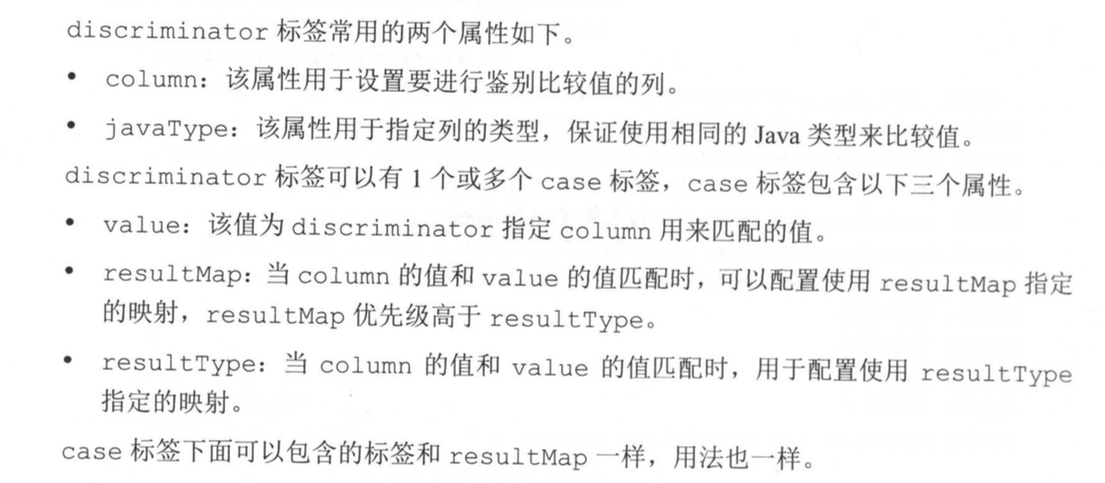

## 6.2 存储过程

创建四个存储过程

|  |
| --- |
| **# 第一个存储过程**  **# 根据用户id查询用户其他信息**  **# 方法看起来很奇怪，但是展示了多个输出参数**  **DROP PROCEDURE IF EXISTS `select_user_by_id`;**  **DELIMITER $$ # 用于设置结束符号的**  **CREATE PROCEDURE `select_user_by_id` (**  **IN userId BIGINT,**  **OUT userName VARCHAR(50),**  **OUT userPassword VARCHAR(50),**  **OUT userEmail VARCHAR(50),**  **OUT userInfo TEXT,**  **OUT headImg BLOB,**  **OUT createTime DATETIME**  **)**  **BEGIN**  **# 根据用户id查询其他数据**  **select user_name,user_password,user_email,user_info,head_img,create_time**  **INTO userName, userPassword, userEmail, userInfo, headImg, createTime**  **from sys_user**  **WHERE id = userId ;**  **END $$**  **DELIMITER ;**  **# 第二个存储过程**  **# 简单根据用户名和分页参数进行查询，返回总数和分页数据**  **DROP PROCEDURE IF EXISTS `select_user_page`;**  **DELIMITER ;;**  **CREATE PROCEDURE `select_user_page` (**  **IN userName VARCHAR(50),**  **IN _offset BIGINT,**  **IN _limit BIGINT,**  **OUT total BIGINT**  **)**  **BEGIN**  **# 查询数据总数**  **select count(*) INTO total**  **from sys_user**  **where user_name like concat('%',userName,'%');**  **# 分页查询数据**  **select * from sys_user**  **where user_name like concat ('%',userName,'%')**  **limit _offset, _limit;**  **END**  **;;**  **DELIMITER ;**  **# 第三个存储过程**  **# 保存用户信息和角色关联信息**  **DROP PROCEDURE IF EXISTS `insert_user_and_roles`;**  **DELIMITER ;;**  **CREATE PROCEDURE `insert_user_and_roles`(**  **OUT userId BIGINT,**  **IN userName VARCHAR(50),**  **IN userPassword VARCHAR(50),**  **IN userEmail VARCHAR(50),**  **IN userInfo TEXT,**  **IN headImg BLOB,**  **OUT createTime DATETIME,**  **IN roleIds varchar(200)**  **)**  **BEGIN**  **# 设置当前时间**  **SET createTime = NOW();**  **INSERT INTO sys_user(user_name,user_password,user_email,user_info,head_img,create_time)**  **values (userName,userPassword,userEmail,userInfo,headImg,createTime);**  **# 获取自增主键**  **SELECT LAST_INSERT_ID() INTO userId;**  **# 保存用户和角色关系数据**  **SET roleIds = CONCAT(',',roleIds,',');**  **INSERT INTO sys_user_role(user_id,role_id)**  **select userId,id from sys_role**  **where INSTR(roleIds,CONCAT(',',id,',')) > 0;**  **END**  **;;**  **DELIMITER ;**  **# 第四个存储过程**  **# 删除用户信息和角色关联信息**  **DROP PROCEDURE IF EXISTS `delete_user_by_id`;**  **DELIMITER ;;**  **CREATE PROCEDURE `delete_user_by_id` (IN userId BIGINT)**  **BEGIN**  **DELETE FROM sys_user_role where user_id = userId;**  **DELETE FROM sys_user where id = userId;**  **END**  **;;**  **DELIMITER ;** |

### 6.2.1 第一个存储过程

### 6.2.2 第二个存储过程

### 6.2.3 第三个和第四个存储过程

### 6.2.4 在oracle中使用游标参数

略

在UserMapper.java中添加方法

|  |
| --- |
| */**  * 使用存储过程查询用户信息  *  \** ***@param*** *user  */* void selectUserById(SysUser user);  */**  * 使用存储过程分页查询  *  \** ***@param*** *params  \** ***@return*** *\*/* List<SysUser> selectUserPage(Map<String, Object> params);   */**  * 存储过程进行新增  *  \** ***@param*** *user  \** ***@param*** *roleIds  \** ***@return*** *\*/* int insertUserAndRoles(@Param("user") SysUser user, @Param("roleIds") String roleIds);  */**  * 根据用户Id删除用户和用户的角色信息  *  \** ***@param*** *id  \** ***@return*** *\*/* int deleteUserById(Long id); |

在UserMapper.xml

|  |
| --- |
| <!--  selectUserById:在使用select标签调用存储过程时，由于存储过程不支持MyBatis的二级缓存(后面章节会介绍)，  因此为了避免缓存配置出错，直接将select标签的useCache属性设置为false。   mode: 可选值IN, OUT, INOUT 三种。入参使用IN，出餐使用OUT，输入输出INOUT    --> <select id="selectUserById" statementType="CALLABLE" useCache="false">  { call select_user_by_id (  #{id,mode=IN},  #{userName,mode=OUT,jdbcType=VARCHAR},  #{userPassword,mode=OUT,jdbcType=VARCHAR},  #{userEmail,mode=OUT,jdbcType=VARCHAR},  #{userInfo,mode=OUT,jdbcType=VARCHAR},  #{headImg,mode=OUT,jdbcType=BLOB,javaType=byte[]},  #{createTime,mode=OUT,jdbcType=TIMESTAMP}  )  } </select>  <select id="selectUserPage" statementType="CALLABLE" useCache="false" resultMap="userMap">  {call select_user_page (  #{userName,mode=IN},  #{offset,mode=IN},  #{limit,mode=IN},  #{total,mode=OUT,jdbcType=BIGINT}  )} </select>   <select id="insertUserAndRoles" statementType="CALLABLE">  {call insert_user_and_roles(  #{user.id,mode=OUT,jdbcType=BIGINT},  #{user.userName,mode=IN},  #{user.userPassword,mode=IN},  #{user.userEmail,mode=IN},  #{user.userInfo,mode=IN},  #{user.headImg,mode=IN,jdbcType=BLOB},  #{user.createTime,mode=OUT,jdbcType=TIMESTAMP},  #{roleIds,mode=IN}  )} </select>  <delete id="deleteUserById" statementType="CALLABLE">  {call delete_user_by_id (  #{id,mode=IN}  )} </delete> |

在UserMapperTest.java

|  |
| --- |
| @Test  public void testSelectUserById() {  SqlSession sqlSession = *getSqlSession*();   try {  UserMapper userMapper = sqlSession.getMapper(UserMapper.class);  SysUser user = new SysUser();  user.setId(1L);  userMapper.selectUserById(user);   *assertNotNull*(user.getUserName());  System.*out*.println("用户名：" + user.getUserName());  } finally {  sqlSession.close();  }  }    @Test  public void testSelectUserPage() {  SqlSession sqlSession = *getSqlSession*();   try {  UserMapper userMapper = sqlSession.getMapper(UserMapper.class);  Map<String, Object> params = new HashMap<>();  params.put("userName", "ad");  params.put("offset", 0);  params.put("limit", 10);   List<SysUser> userList = userMapper.selectUserPage(params);  Long total = (Long) params.get("total");   System.*out*.println("总数：" + total);  for (SysUser user : userList) {  System.*out*.println("用户名：" + user.getUserName());  }  } finally {  sqlSession.close();  }  }    @Test  public void testInsertAndDelete() {  SqlSession sqlSession = *getSqlSession*();   try {  UserMapper userMapper = sqlSession.getMapper(UserMapper.class);   SysUser user = new SysUser();  user.setUserName("test1");  user.setUserPassword("123456");  user.setUserEmail("test@mybatis.tk");  user.setUserInfo("test info");   user.setHeadImg(new byte[]{1, 2, 3});   userMapper.insertUserAndRoles(user, "1,2");  *assertNotNull*(user.getId());  *assertNotNull*(user.getCreateTime());  // sqlSession.commit();  // 测试删除刚刚插入的数据  userMapper.deleteById(user.getId());   } finally {  sqlSession.close();  }  } |

## 6.3 使用枚举或其他对象

### 6.3.1 使用Mybatis提供的枚举处理器

在model包中增加Enable.java 枚举类

|  |
| --- |
| package com.mybatis.book.study.model;  public enum Enabled {   *disabled*,//禁用  *enabled*,//启用  } |

在mybatis-config.xml中增加 typeHandlers配置

|  |
| --- |
| <?xml version="1.0" encoding="UTF-8"?> <!DOCTYPE configuration PUBLIC "-//mybatis.org//DTD Config 3.0//EN"  "http://mybatis.org/dtd/mybatis-3-config.dtd"> <configuration>  <settings>  <!-- 输出的日志-->  <setting name="logImpl" value="LOG4J"/>  <!-- true 可以自动将以下划线方式命名的数据库列映射到Java对象的驼峰式命名属性中-->  <setting name="mapUnderscoreToCamelCase" value="true"/>  <!-- 是否延迟加载：false懒加载-->  <setting name="aggressiveLazyLoading" value="false"/>   </settings>    <typeAliases>  <!-- 实体对应的包-->  <package name="com.mybatis.book.study.model"/>  </typeAliases>    <!-- 这些配置还有顺序，注意typeHandlers的位置不要放在typeAliases前面-->  <typeHandlers>  <typeHandler javaType="com.mybatis.book.study.model.Enabled"  handler="org.apache.ibatis.type.EnumOrdinalTypeHandler"/>  </typeHandlers>   <!-- <databaseIdProvider type="DB_VENDOR">-->  <!-- <property name="SQL" value="sqlserver"/>-->  <!-- <property name="DB2" value="db2"/>-->  <!-- <property name="Oracle" value="oracle"/>-->  <!-- <property name="MySQL" value="mysql"/>-->  <!-- <property name="PostgreSQL" value="postgresql"/>-->  <!-- <property name="Derby" value="derby"/>-->  <!-- <property name="HSQL" value="hsqldb"/>-->  <!-- <property name="H2" value="h2"/>-->  <!-- </databaseIdProvider>-->   <!-- 数据源配置-->  <environments default="development">  <environment id="development">  <transactionManager type="JDBC">  <property name="" value=""/>  </transactionManager>  <dataSource type="UNPOOLED">  <property name="driver" value="com.mysql.jdbc.Driver"/>  <property name="url" value="jdbc:mysql://localhost:3306/mybatis-study"/>  <property name="username" value="root"/>  <property name="password" value="mysql"/>  </dataSource>  </environment>  </environments>    <mappers>  <!-- 映射文件所在位置-->  <mapper resource="mappers/CountryMapper.xml"></mapper>  <mapper resource="mappers/UserMapper.xml"></mapper>  <mapper resource="mappers/RoleMapper.xml"></mapper>  <mapper resource="mappers/PrivilegeMapper.xml"></mapper>  <mapper resource="mappers/UserRoleMapper.xml"></mapper>  <mapper resource="mappers/RolePrivilegeMapper.xml"></mapper>  </mappers>  </configuration> |

在RoleMapperTest.java

|  |
| --- |
| @Test public void testUpdateId(){  SqlSession sqlSession = *getSqlSession*();  try {   // 若是mybatis-config.xml中没有配置typeHandlers 则运行该测试会报错  RoleMapper roleMapper = sqlSession.getMapper(RoleMapper.class);   SysRole sysRole = roleMapper.selectById(2L);  *assertEquals*(Enabled.*enabled*,sysRole.getEnabled());   sysRole.setEnabled(Enabled.*disabled*);  roleMapper.updateById(sysRole);   }finally {  sqlSession.rollback();  sqlSession.close();  }  } |

### 6.3.2 自定义类型处理器

修改Enabled.java枚举类

|  |
| --- |
| package com.mybatis.book.study.model;  public enum Enabled {   *disabled*(1),//禁用  *enabled*(0),  ;//启用   private final int value;   Enabled(int value) {  this.value = value;  }   public int getValue() {  return value;  } } |

新增type包，同时新增EnableTypeHandler类

|  |
| --- |
| package com.mybatis.book.study.type;  import com.mybatis.book.study.model.Enabled; import org.apache.ibatis.type.JdbcType; import org.apache.ibatis.type.TypeHandler;  import java.sql.CallableStatement; import java.sql.PreparedStatement; import java.sql.ResultSet; import java.sql.SQLException; import java.util.HashMap; import java.util.Map;  public class EnabledTypeHandler implements TypeHandler<Enabled> {   private final Map<Integer,Enabled> enabledMap = new HashMap<>();   public EnabledTypeHandler() {  for (Enabled value : Enabled.*values*()) {  enabledMap.put(value.getValue(),value);  }  }   @Override  public void setParameter(PreparedStatement preparedStatement, int i, Enabled enabled, JdbcType jdbcType) throws SQLException {  preparedStatement.setInt(i,enabled.getValue());  }   @Override  public Enabled getResult(ResultSet resultSet, String columnName) throws SQLException {  int value = resultSet.getInt(columnName);  return enabledMap.get(value);  }   @Override  public Enabled getResult(ResultSet resultSet, int columnIndex) throws SQLException {  int value = resultSet.getInt(columnIndex);  return enabledMap.get(value);  }   @Override  public Enabled getResult(CallableStatement callableStatement, int columnIndex) throws SQLException {  int value = callableStatement.getInt(columnIndex);  return enabledMap.get(value);  } } |

修改配置mybatis-config.xml中的typeHandlers配置

|  |
| --- |
| <!-- 这些配置还有顺序，注意typeHandlers的位置不要放在typeAliases前面-->  <typeHandlers> <!-- <typeHandler javaType="com.mybatis.book.study.model.Enabled"--> <!-- handler="org.apache.ibatis.type.EnumOrdinalTypeHandler"/>-->   <typeHandler javaType="com.mybatis.book.study.model.Enabled"  handler="com.mybatis.book.study.type.EnabledTypeHandler"/>  </typeHandlers> |

重新运行测试类，可以正常运行

### 6.3.3 对Java8日期支持

增加pom依赖

<dependency>  
 <groupId>org.mybatis</groupId>  
 <artifactId>mybatis-typehandlers-jsr310</artifactId>  
 <version>1.0.2</version>  
</dependency>

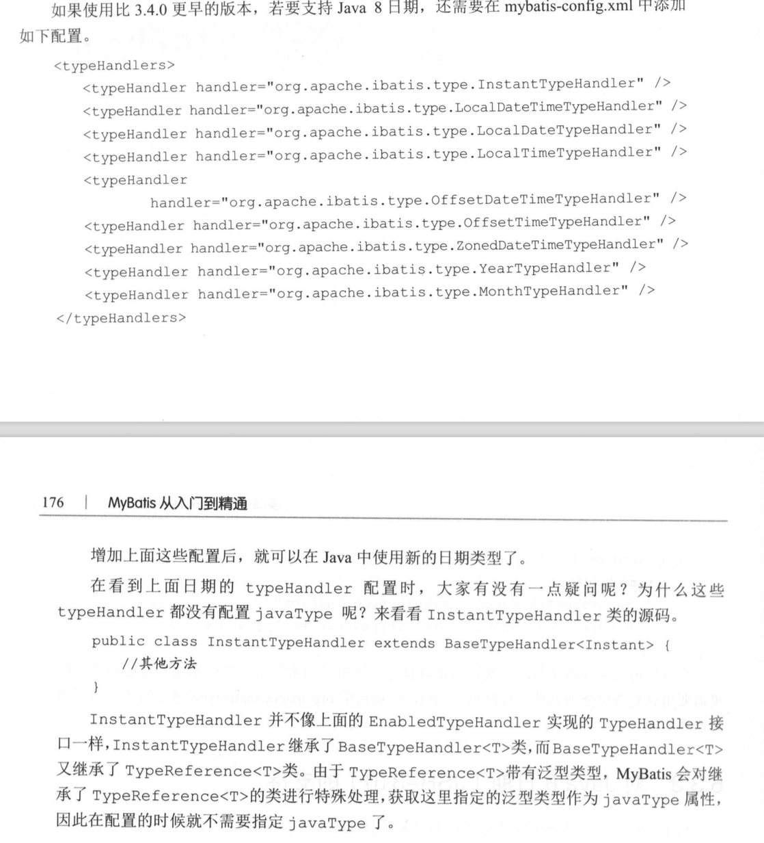

# **7 Mybatis 缓存配置**

一般提到Mybatis缓存的额时候，都是指二级缓存。一级缓存(也叫本地缓存)，默认是开启的，并且不能控制。

## 7.1 一级缓存

增加测试类CacheTest.java

|  |
| --- |
| package com.mybatis.book.study;  import com.mybatis.book.study.mapper.UserMapper; import com.mybatis.book.study.model.SysUser; import org.apache.ibatis.session.SqlSession; import org.junit.Assert; import org.junit.Test;  import static org.junit.Assert.*;  public class CacheTest extends BaseMapperTest {    @Test  public void testL1Cache() {   SqlSession sqlSession = *getSqlSession*();  SysUser user1 = null;  try {  UserMapper userMapper = sqlSession.getMapper(UserMapper.class);   user1 = userMapper.selectById(1L);  user1.setUserName("New Name");  // 没有发送sql查询  SysUser user2 = userMapper.selectById(1L);   *assertEquals*("New Name", user2.getUserName());  *assertEquals*(user1, user2);   } finally {  sqlSession.close();  }   System.*out*.println("开启新的sqlSession");   sqlSession = *getSqlSession*();   try {  UserMapper userMapper = sqlSession.getMapper(UserMapper.class);  SysUser user2 = userMapper.selectById(1L);  *assertEquals*("New Name",user2.getUserName());  *assertEquals*(user1,user2);   userMapper.deleteById(2L);   SysUser user3 = userMapper.selectById(1L);  *assertNotEquals*(user2,user3);    }finally {  sqlSession.close();  }    }   }  执行结果：从下面结果中可以看到，同一个sqlSession期间的同一个方法的查询，不会发sql去查询，查询的缓存(即不发送sql去数据库查询)。  DEBUG [main] - ==> Preparing: select * from sys_user where id = ?  DEBUG [main] - ==> Parameters: 1(Long)  TRACE [main] - <== Columns: id, user_name, user_password, user_email, user_info, head_img, create_time  TRACE [main] - <== Row: 1, admin, 123456, admin@mybatis.tk, <<BLOB>>, <<BLOB>>, 2019-10-25 16:00:00.0  DEBUG [main] - <== Total: 1  开启新的sqlSession  Sat Nov 02 10:34:32 CST 2019 WARN: Establishing SSL connection without server's identity verification is not recommended. According to MySQL 5.5.45+, 5.6.26+ and 5.7.6+ requirements SSL connection must be established by default if explicit option isn't set. For compliance with existing applications not using SSL the verifyServerCertificate property is set to 'false'. You need either to explicitly disable SSL by setting useSSL=false, or set useSSL=true and provide truststore for server certificate verification.  DEBUG [main] - ==> Preparing: select * from sys_user where id = ?  DEBUG [main] - ==> Parameters: 1(Long)  TRACE [main] - <== Columns: id, user_name, user_password, user_email, user_info, head_img, create_time  TRACE [main] - <== Row: 1, admin, 123456, admin@mybatis.tk, <<BLOB>>, <<BLOB>>, 2019-10-25 16:00:00.0  DEBUG [main] - <== Total: 1  org.junit.ComparisonFailure:  Expected :New Name  Actual :admin  <Click to see difference>  at org.junit.Assert.assertEquals(Assert.java:115)  at org.junit.Assert.assertEquals(Assert.java:144)  at com.mybatis.book.study.CacheTest.testL1Cache(CacheTest.java:40)  at sun.reflect.NativeMethodAccessorImpl.invoke0(Native Method)  at sun.reflect.NativeMethodAccessorImpl.invoke(NativeMethodAccessorImpl.java:62)  at sun.reflect.DelegatingMethodAccessorImpl.invoke(DelegatingMethodAccessorImpl.java:43)  at java.lang.reflect.Method.invoke(Method.java:498)  at org.junit.runners.model.FrameworkMethod$1.runReflectiveCall(FrameworkMethod.java:50)  at org.junit.internal.runners.model.ReflectiveCallable.run(ReflectiveCallable.java:12)  at org.junit.runners.model.FrameworkMethod.invokeExplosively(FrameworkMethod.java:47)  at org.junit.internal.runners.statements.InvokeMethod.evaluate(InvokeMethod.java:17)  at org.junit.runners.ParentRunner.runLeaf(ParentRunner.java:325)  at org.junit.runners.BlockJUnit4ClassRunner.runChild(BlockJUnit4ClassRunner.java:78)  at org.junit.runners.BlockJUnit4ClassRunner.runChild(BlockJUnit4ClassRunner.java:57)  at org.junit.runners.ParentRunner$3.run(ParentRunner.java:290)  at org.junit.runners.ParentRunner$1.schedule(ParentRunner.java:71)  at org.junit.runners.ParentRunner.runChildren(ParentRunner.java:288)  at org.junit.runners.ParentRunner.access$000(ParentRunner.java:58)  at org.junit.runners.ParentRunner$2.evaluate(ParentRunner.java:268)  at org.junit.internal.runners.statements.RunBefores.evaluate(RunBefores.java:26)  at org.junit.runners.ParentRunner.run(ParentRunner.java:363)  at org.junit.runner.JUnitCore.run(JUnitCore.java:137)  at com.intellij.junit4.JUnit4IdeaTestRunner.startRunnerWithArgs(JUnit4IdeaTestRunner.java:68)  at com.intellij.rt.execution.junit.IdeaTestRunner$Repeater.startRunnerWithArgs(IdeaTestRunner.java:47)  at com.intellij.rt.execution.junit.JUnitStarter.prepareStreamsAndStart(JUnitStarter.java:242)  at com.intellij.rt.execution.junit.JUnitStarter.main(JUnitStarter.java:70) |

通过配置select flushCache=“true”清楚缓存影响

修改UserMapper.xml中的selectById

|  |
| --- |
| <!--  flushCache：每次查询时，清空一级缓存(sqlSession)， --> <select id="selectById" flushCache="true" resultMap="userMap">  select * from sys_user where id = #{id} </select> |

在次执行测试类，可以发现，每次查询都重新查询了数据库

## 7.2 二级缓存

### 7.2.1 配置二级缓存

**7.2.1.1 Mapper.xml中配置二级缓存**

先在mybatis-config.xml中增加配置，开启缓存

<!--  
 二级 缓存配置：二级缓存需要配置在Mapper.xml映射文件中或者配置在Mapper。java接口中。在映射文件中，命名空间就是Xml根节点mapper的namespace属性  
-->  
<setting name="cacheEnabled" value="true"/>

在RoleMapper.xml增加cache配置

|  |
| --- |
| <!--  二级缓存会有如下效果：  映射语句文件中的所有SELECT语句将会被缓存  映射语句文件中的所有INSERT、UPDATE、DELTE语句会刷新缓存  缓存会使用Least Recently Used(LRU,最近最少使用的)算法来收回  根据时间表(如no Flush Inteerval,没有刷新间隔)，缓存不会以任何时间顺序来刷新  缓存会存储集合或对象(无论查询方法返回什么类型的值)的1024个引用。  缓存会被视为read/write（可读/可写）的，意味着对象检索不是共享的，  而且可以安全地调用者修改，而不干扰其他调用者或线程所做的潜在修改。   evication(收回策略)：  LRU(最近最少使用的):移除最长时间不被使用的对象，这是默认值  FIFO(先进先出)：按对象进入缓存的顺序来移除他们。  SOFT(软引用): 移除基于垃圾回收器  WEAK(弱引用)：更积极地移除基于垃圾收集器状态和弱引用规则的对象   flushInterval(刷新间隔)：可以被设置为任意的正整数，而且他们代一个合理的毫秒形式的时间段。  默认情况下，既没有刷新间隔，缓存仅仅在调用语句时刷新  readOnly（只读）：属性可以被设置为true或false。只读的缓存会给所有调用者返回缓存对象的相同实例，因此这些对象不能被修改，这提供了很重要的性能优势。  可以读写的缓存会通过序列化返回焕春对象的拷贝，这种方式会慢一些，但是安全写，因此默认是false --> <cache eviction="FIFO" flushInterval="60000" size="512" readOnly="true"/> |

**7.2.1.1 Mapper接口中配置二级缓存**

在RoleMapper.java配置注解缓存

|  |
| --- |
| package com.mybatis.book.study.mapper;  import com.mybatis.book.study.model.SysRole; import org.apache.ibatis.annotations.*; import org.apache.ibatis.cache.decorators.FifoCache;  import java.util.List;   */**  *  *  * readWrite和select标签中的readOnly属性一样  * 这里true为读写，false为只读  */* //@CacheNamespace( // eviction = FifoCache.class, // flushInterval = 60000, // size = 512, // readWrite = true //)  */**  *   * 参照缓存  */* @CacheNamespaceRef(RoleMapper.class) public interface RoleMapper {     } |

### 7.2.2 使用二级缓存

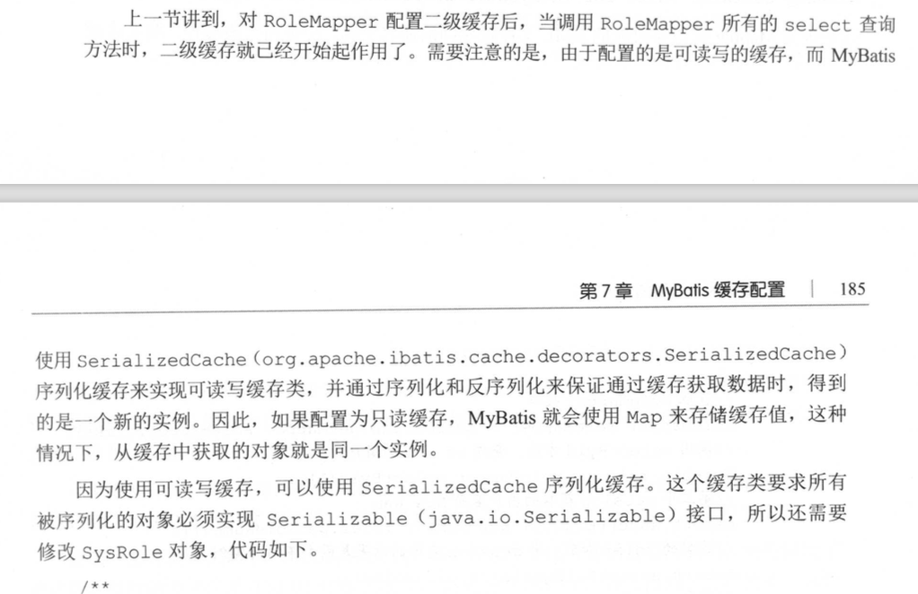

在CacheTest.java

|  |
| --- |
| @Test public void testL2Cache() {  SqlSession sqlSession = *getSqlSession*();   SysRole role1 = null;  try {  RoleMapper roleMapper = sqlSession.getMapper(RoleMapper.class);   role1 = roleMapper.selectById(1L);  role1.setRoleName("New Name");   SysRole role2 = roleMapper.selectById(1L);  System.*out*.println("role2Name=" + role2.getRoleName());   // 这里role1和role2是由于sqlSession缓存查询的结果，是同一个实例  *assertEquals*(role1,role2);   } finally {  sqlSession.close();  }    System.*out*.println("开启新的SqlSession");  sqlSession = *getSqlSession*();  try {  RoleMapper roleMapper = sqlSession.getMapper(RoleMapper.class);   SysRole role2 = roleMapper.selectById(1L);  System.*out*.println("role2Name=" + role2.getRoleName());  // 这里role1是上一个sqlSession结果，role2是二级缓存的结果，所以连个不是同一个实例(这里感觉不太对啊)  *assertNotEquals*(role1,role2);  SysRole role3 = roleMapper.selectById(1L);  // role2和role3 是两个实例(这里感觉不太对啊)  *assertNotEquals*(role2,role3);  } finally {  sqlSession.close();  }  } |

## 7.3 集成EhCache缓存

EhCache是一个纯粹的Java进程内的缓存框架，具有快速、精干等特性，如下：

1. 快速
2. 简单
3. 多种缓存策略
4. 缓存数据有内存和磁盘两级，无须担心容量问题
5. 缓存数据会在虚拟机重启的过程中写入磁盘
6. 可以通过RMI、可插入API等方式进行分布式缓存
7. 具有缓存和缓存管理器的侦听接口。
8. 支持多缓存管理器实例以及一个实例的多个缓存区域

## 7.4 集成Redis缓存

## 7.5 脏数据的产生和避免

## 7.6 二级缓存使用场景

在一下场景中，推荐使用二级缓存。

1.以查询为主的应用中，只有尽可能少的增、删、该操作。

2.绝大多数以单表操作存在时，由于很少存在互相关联的情况，因此不会出现脏数据

3.可以按业务划分对表进行分组时，如关联的表比较少，可以通过参照缓存进行配置。

# **8 Mybatis 插件开发**

# **9 Spring集成Mybatis**

# **10 Springboot 集成Mybatis**